NAME _____________________________________ **UNIT 5**: NUCLEAR CHEMISTRY

There are only a few goals I wish you to master for this entire unit:

* To understand that the mass defect associated with nuclear changes is the source of nuclear energy
* To understand how nuclear energy is used to produce electricity via a nuclear power plant.
* To compare/contrast nuclear fission and nuclear fusion

**I) Comparing Reaction Chemistry to Nuclear Chemistry …. a.k.a. My Worst Fear re: Comparison…**

|  |  |
| --- | --- |
| *REACTION CHEMISTRY* | ***NUCLEAR CHEMISTRY*** |
| Chemical reactions (redox, neutralization,  polymerization…) & Physical changes | **Nuclear Transmutations: Natural, Artificial**  **and reactions like Fission or Fusion.** |
| uses words like: ions, bonds, polar, soluble  covalent, stoichiometry, ionic, molecules, | **uses words like: nuclide, isotope, half-life**  **nuclear transmutation, radiation,**  **Radioisotope, natural decay** |
| reactions are due to the loss / gain or to  the sharing of valence e- or of H+1 (acids) | **reactions are due to changes in the structure**  **or energy of the nucleus itself. These**  **reactions release more energy than chemical**  **reactions** |
| No changes occur in the nucleus. We focus  upon the action of the outer electrons. | **electrons outside the nucleus are of lesser,**  **concern than the nucleus, with this topic** |

I) Nuclear chemistry is the study of the changes that occur in the *nucleus and the tremendous energy

transformation involved. This is a specialized area of study. It tends to ignore valence electron theory.

**Now, before getting too far into the topic … I want to discuss the four basic forces of nature, and give you an overview of the field called Nuclear Chemistry.**

**Then I want to send you off to a PowerPoint to learn all about Natural Decay.**

II) The Fundamental (Force) Interactions

A) Classically there are four forces chemists and physicists discuss, they are:

* gravitational force (gravity)
* electromagnetic force (the stuff of chemistry … the electromagnetic spectrum… bond energy)
* *the weak nuclear force
* *the strong nuclear force

1) Everyone knows about gravity … It’s everywhere … It’s associated with mass.

a) The greater the mass of an object, the greater its gravitational force … So, I have a

gravitational force, the Earth does, and a paper clip does. In fact, when we think about

it, gravity is sort of interesting … I mean, I can pick up a paper clip … **Look Mom …I am**

**overcoming gravity!**  Whoop De Doo!

b) Electromagnetic force … ahh … bond energy (potential energy), cations attracting anions,

electron configuration, the production of light, and thermal energy, etc.…

c) *Weak force … keeps that proton to an electron, to make a neutron. It is involved radioactive

issues, such as fission, fusion, and ultimately the formation of matter!

* **Check out**: Weak Force: <https://www.youtube.com/watch?v=J4Ej3Q_QquA>

i) it’s stronger than the gravitational force (!) but it works only over incredibly short

distances, like the diameter of a proton…

d) *Strong force … Ahh! Now, you know all about this … This is how a nucleus of positive

protons and neutral neutrons is held together … in more ways than one! This is the force

which actually holds the quarks of a single proton to each other. And, this harkens back to

that meson transfer between the nucleons holding the whole nucleus together … It is the duct

tape of the atomic nucleus … (go back to page 36 (Unit 2) of your notes and review what I

mean … if you wish). (As a side note: gluons hold quarks together, which make a proton or

neutron … a meson carries the force which holds protons to neutrons to make a nucleus…)

B) Nuclear chemistry is concerned primarily with the strong force, and weak force.

The strong force helps to explain alpha decay and the weak force helps to explain beta decay as well

as nuclear fusion (more later).

III) Overview:

NUCLEAR CHEMISTRY

Transmutations & Related Nuclear Changes

Basics of an atom's nucleus

Nuclear Radiation

neutrons

Ionizing Radiation

Radioisotopes

protons

Fission & Fusion

Natural

Decays

Energy of...

mass number

Uses:

Diagnostic

Treatment

Commercial

Research

Artificial

alpha, beta, and gamma!

mass defect

& E= mc2

nuclear power plant

A) You know all about protons and neutrons (the nucleons of an atom’s nucleus). You know about

isotopes and mass number … no big deal….

B) However, we must get a fair amount of new vocabulary under the belt, as it were….

* + - Natural Decay (Natural (Nuclear) Transmutation)
    - Nuclear Transmutation
    - Artificial Transmutation
    - Nuclide (pronounced as new-k-lied … with a long “I” sound)
    - Fisson
    - Fusion ….

C) To get you started I want you to go to the Alpha Beta Gamma Decay PowerPoint … Get a good

sense of the vocabulary and the processes.

IV) Summary of Some of The Discussed Particles in Nuclear Chemistry

|  |  |  |  |  |
| --- | --- | --- | --- | --- |
| Properties of Radiation | Alpha Particle | Beta Particle | Gamma Ray | Neutron |
| Symbol | α or ${}_{2}^{4}{He}$ | β, β- or ${}_{-1}^{0}e$ | γ | $${}_{0}^{1}n$$ |
| Mass (μ) | 4 | 1/1836 virtually 0 | 0 | 1 |
| Charge | +2 | -1 | 0 | 0 |
| Speed | Slow | Fast | Speed of light | Mixed / Slow used in atomic bomb… Fast used to make  Pu-239 |
| Ionizing Ability | High | Medium | Causes ionization, indirectly | Like gamma rays, they cause ionization indirectly |
| Penetrating Power | Low | Medium | High | Very High.. Of the 4 types of radiation discussed here, they are the only form that can make other atoms, radioactive via bombardment |
| Stopped By: | Paper | Skin | Concrete and Lead | Can be absorbed by boron, cadmium, silver and indium metals |
| Comment | (High energy helium nucleus made of 2 p and 2 n and no electrons | High energy electrons ejected from the nucleus due to the decay of a neutron | Pure energy… no mass, no charge… very high energy electromagnetic wave | Bombardment with neutrons causes nuclear fission. It has no charge and therefore can penetrate the nucleus very effectively. |

A) Recall, each of the natural decays (alpha, beta, gamma) have ONLY 1 reactant.

1) An alpha decay MUST produce a He-4 nucleus ( ${}_{2}^{4}{He}$ or its symbol: α)

a) **KNOW THIS: When there is only 1 reactant AND He-4 is a product it is an**

**alpha decay.** **All alpha decays must have He-4 as a product …. but not all**

**nuclear changes which have He-4 as a product are alpha decays … (**Sort of like

all women are people, but not all people are women). **He-4 is sometimes produced**

**and not via an alpha decay** ….

**Again: To be an alpha decay … 1 reactant …. and He-4 as a product…**

When there are 2 reactants and one of the products happens to be He-4 … it is not

classified as an alpha decay ….. It could be an artificial transmutation. Artificial

transmutations have **2 reactants** and they use high speed particles to slam into

non-radioactive atoms … and cause those non-radioactive atoms, to become

radioactive! … It’s sort of like if I kept punching you (a very calm and considerate

person) in the shoulder … You might go bonkers and lose it after a time. That’s artificial

transmutation …. And, Irene Curie and Frederick Joliot-Curie …the daughter and

son-in-law of Marie and Pierre Curie … won the Nobel Prize for this discovery.

**This is an alpha decay**: 1 reactant … and one of the products is ${}_{2}^{4}{He}$

${}_{90}^{232}{Th}$**→ ${}_{2}^{4}{He}$ + ${}_{88}^{228}{Ra}$**

This following is NOT an alpha decay … even though ${}_{2}^{4}{He}$ is a product …

because there are 2 reactants … This happens to be an artificial transmutation.

${}_{82}^{210}{Pb}$**+ ${}_{0}^{1}n$ → ${}_{80}^{207}{Hg}$ + ${}_{2}^{4}{He}$**

Pb-210 happens to be uber-stable … but it can be made to transmute, if

bombarded with neutrons.

2) A beta decay MUST produce an electron ( ${}_{-1}^{0}e$ or its symbol: β-), and have only 1 reactant.

3) A gamma decay is the release of pure energy … it is not technically a transmutation….

(refer to the PowerPoint as to why)

V) Balancing and Predicting Products of a Nuclear Change

A) Just like "regular" chemical equations, nuclear equations must be balanced.

1) Make sure that the sum of the mass numbers on the reactant side is equal to the sum of the

mass numbers on the product side. **Also**

2) Make sure that the sum of the atomic numbers (or charges) on the reactant side is equal to

the sum of the atomic numbers (or charges) on the product side.

HUH? Make sure that the numbers along the top add up to each other …. The left

side top numbers must equal the sum of the right side’s top numbers

And, make sure that the numbers along the bottom add up to each other… The

left side’s bottom numbers must equal the sum of the right side’s bottom

numbers.

**You will need to use a periodic table … so get one out!**

4) Symbolically speaking: **Z** + **C** → **F** + **I**

The sum of **x +a** must = the sum of **d + g**

and

The sum of **y + b** must = the sum of **e + h**

Notice: The sum of the top numbers on the product side: 4+ 228 equals the

mass number of the reactant, 232

5) Examples

a) ${}_{90}^{232}{Th}$ → ${}_{2}^{4}{He}$ + ${}_{88}^{228}{Ra}$

Notice: The sum of the atomic numbers on the product side: 2+ 88 equals the atomic number of the reactant, 90

Notice: The sum of 210 + 1 = 207 + 4

b) ${}_{82}^{210}{Pb}$ + ${}_{0}^{1}n$ → ${}_{80}^{207}{Hg}$ + ${}_{2}^{4}{He}$

Notice: The sum of 82 + 0 = 80 + 2

Again … The sum of the mass numbers on the reactant side, must equal the sum of

the mass numbers on the product side.

And, the sum of the atomic numbers on the reactant side, must equal the sum

of the atomic numbers on the product side.

Now, armed with a periodic table you can PREDICT the products of a nuclear reaction!!!! Yes, You Can!

c) Given: N + n 🡪 C + _________

⮱ identify the particle

**For the mass number**: 14 + 1 = 15 so 14 + ? = 15 …. Yep, the mass number is 1

**Now for the atomic number**: 7 + 0 = 7 so 6 + ? = 7 … Yep, the atomic number is 1

**Go to the periodic table** … Find atomic number 1’s symbol …. It’s H

Thus, the second product is ${}_{1}^{1}H$

d) Given: 

⮱ identify the particle

**For the mass number**: 99 is the total on the reactant side

so, 0 + ? = 99? …. Yep … the mass number = 99

**For the atomic number**: 43 is the total on the reactant side … Now, a little tricky…

(-1) + ? = 43 or rather …. What number -1 = 43?

Yep, this is a beta decay, and the atomic # goes up to 44.

**Go to the periodic table**, look up atomic number 44 … It’s Ru … so the new product is

${}_{44}^{99}{Ru}$!!!! That’s it!

VI) Some radioisotopes are used for medical diagnostic / scientific procedures or treatments:

|  |  |
| --- | --- |
| Isotope | Use |
| **✯✯✯** I-131  (iodine-131)  Hyperthyroidism (over active) & hypothyroidism (underactive) …  Gamma emitter | **Diagnostic and Therapeutic:** This tests the function of the thyroid gland. Normally, the gland absorbs iodide ion and uses it to produce a metabolism controlling hormone * thyroxine . The radioisotope is used to test the efficiency of the absorption of the iodide ion. |
| Co-60 and/or Cs-137  (cobalt-60 & cesium -137)  Beta emitters & Cs-137 is also a gamma emitter | **Therapeutic:** Cancer cells are more susceptible to the effects of radiation |
| Tc-99m (meta stable)  (technetium -99m)  Gamma emitter | **Diagnostic:** Used to spot tumors in organs of heavy blood flow: liver, heart and brain |
| C-14 testing  Beta emitter | **Dating:** Used mostly for dating artifacts of human civilization |
| U-238 decaying to Pb-206  Alpha Emitter | **Dating:** Used mostly for dating geologic specimens and sometimes determining the age of the Earth. (other methods may be more accurate) |
| Co-57  Electron-Capture | **Diagnostic:** Used for the detection of defects in the uptake of vitamin B-12 |

A) Medical radioisotopes used in diagnostic procedures have two requirements

* relatively short half-life period and * quick elimination from the body

B) C-14 Dating: Plants and animals that are alive, absorb constant levels of both * C-12 and

C-14 . Upon death, absorption ceases and the radioactive C-14 decays to N-14 at a

known rate, thus the amount of C-12 is constant and the C-14 concentration dwindles. By comparing

the two concentrations in textiles, pottery, bones, the age of the material can be determined.

C) Uranium to Lead Dating and the age of the Earth: When magma cools, little crystals called

* zircon form. They are made of Zr, Si, and O atoms. Zircons also lock a few atoms of

*U-238 into their crystalline lattices. Once formed, the zircon structure prevents any

contaminant (like extra Pb) from entering the rock. Over billions of years, the trapped * U-238

decays to Pb-206 (National Geographic 9/01)

D) PET Scan: Positron Emission Tomography Scan … Often linked to a CT scanner (computed

tomography) giving you a PET-CT scan … offering a more precise diagnosis.

1) A radioactive form of glucose (or another sort of tracer) is injected and accumulates at

various points of the body.

a) Various chemical issues can be diagnosed …. e.g. to see if a cancer has spread or

if a chemotherapy treatment has worked…

b) Hard cancerous tumors can be found using PET-CT scans

VII) Just a note… Half-Life …

**I have chosen not to deal with this idea … as it requires a bit of math …and more direct teaching**

**than I can do with notes…**

But the **Half-life** of a radioisotope is defined as: **the period of time required for ½ the mass of**

**a radioactive sample to decay.**

Some half-life periods are really short … possibly milliseconds. Others, may be days … while

some may be anywhere from tens of thousands to BILLIONS of years.

It works like this … Lets pretend, just as an introduction … that you have **160 grams** of

radioactive element “G”. And, radioactive element, “G” **has a half-life period of 10 days**.

So… Right now (Time 0) you have 160 grams

In 10 days 80 grams

In another 10 days (total 20) 40 grams

In another 10 days (total 30) 20 grams

In another 10 days (total 40) 10 grams

In another 10 days (total 50) 5 grams

In another 10 days (total 60) 2.5 grams

In another 10 days (total 70) 1.25 grams

In another 10 days (total 80) 0.625 grams

In another 10 days (total 90) 0.3125 grams

So, approximately 3 months later, a small amount of the original radioactive sample still

remains!

Notice it can take quite a long period of time to have all of the radioactive material transmute to

something else and/or be eliminated from a system… This is why we say that radioactive wastes

may be a far flung, lingering problem. For instance, U-238, has a half-life period of

4.5 BILLION years …. The USA has about 90,000 metric tons of nuclear waste (not all of it is U-238), in storage…. Think about it…. <https://www.gao.gov/key_issues/disposal_of_highlevel_nuclear_waste/issue_summary>

VIII) MASS DEFECT & BINDING ENERGY

A) As protons and neutrons come together to form a nucleus, * matter is converted to energy

**✰✰✰**1) mass defect: Mass which is converted into energy as protons and neutrons come

together and produce a new nucleus. The formation of a nucleus results in a mass defect.

Read this 👓: In effect, a nucleus is more stable (less likely to undergo nuclear reactions) with a

greater mass conversion (resulting in what is called, the binding energy per nucleon)

The smaller the binding energy value, per nucleon, the more likely some type of

transmutation will occur to that nucleus.

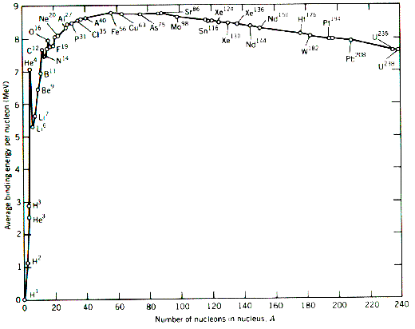

Hence, based upon the above, isotopes of Fe (iron) are among the most stable isotopes

in the world. It could be why there is so much iron in the Earth. At various times,

2.5 billion to 5 billion years ago, the ocean’s were rich in dissolved iron. Either,

H2S and/or O2 reacted with it to “rust” it …

2) A study of the formation of a He-4 nucleus and the mass converted to energy

1.00728 u p

1.00728 u p 2 protons

2 neutrons

1.00867 u n

1.00867 u n 4.00150 u (actual mass)

4.03190 u (theoretical mass) a loss of 0.03040 u

IX) Nuclear Fission

A) Nuclear Fission: The **splitting** of certain heavy and unstable nuclei into smaller nuclei, via

**neutron bombardment** (neutron capture)

1) e.g.) U + n 🡪 Ba + Kr + 3 n + 1.9 x 1010 kJ/mole



(4.6 billion kcal/1mole U-235)

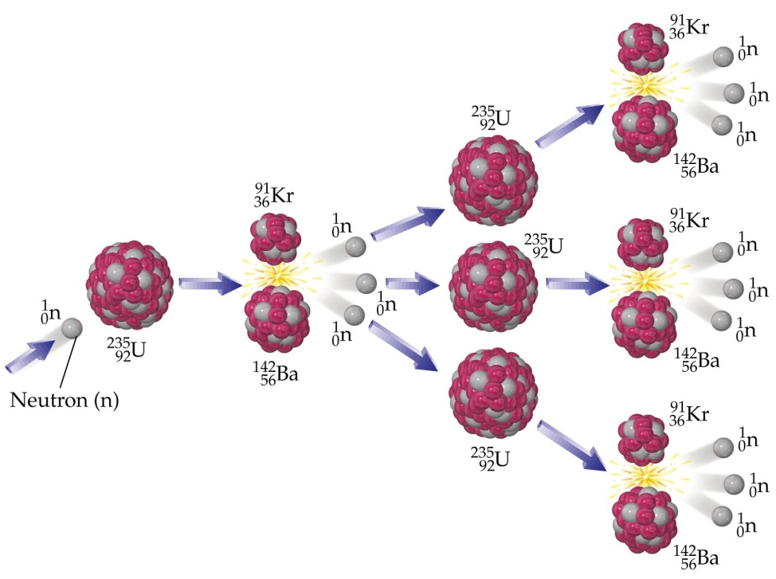

2) As the nuclei split *and the remaining protons and neutrons form into new nuclei*, some mass

is converted into energy.... E = mc2

a) **Don’t forget about the Mass Defect**: As protons and neutrons merge to produce

the new and smaller nuclei of a fission reaction, some of the nuclear mass is converted

into energy. THIS IS THE SOURCE OF THE EXPLOSION … It occurs due to

NEW DAUGHTER NUCLIDES being produced ...**not the splitting of the uranium**,

per se!

b) Recall the formation of a helium nucleus from protons and neutrons:

1.00728 u p

1.00728 u p 2 protons

2 neutrons

1.00867 u n

1.00867 u n 4.00150 u (actual)

4.03190 u (theoretical) a loss of 0.03040 u

3) The atomic bomb used U-235 and Pu-239 as fissionable fuels ... because they are fairly

unstable isotopes (**low binding energies per nucleon**) and really, quite massive

4) Fission Chain reaction: A type of nuclear change in which MANY atoms undergo

changes in their nuclear structure, once a single atom is activated.

a) uncontrolled fission chain reaction = A-Bomb, (Atomic Bomb)

b) controlled fission chain reaction = Nuclear Power Plant

c) Key terms:

i) **subcritical mass**: a sample of **fissile** (sounds like *missile*) material that does not

have the ability to sustain a fission chain reaction. The required neutrons are

allowed to escape to the outside environment, and the total number of neutrons

produced due to successful fissions ultimately, decreases.

e.g. a radioactive sample of uranium ore

ii) **critical mass**: the *smallest* sample of fissile material that can sustain a chain

reaction, with no increase / decrease in the rate of fission.

iii) **supercritical mass**: a sample of fissile material in which there is an

increasing rate in the fission of the fuel atoms.

e.g.) as seen in an A-Bomb .... the supercritical mass ultimately

blows itself apart.... releasing the energy due to the mass defect,

and the waste products of fission. Thus, after the explosion, the

remaining fuel is at a subcritical mass.

d) different isotopes have different supercritical masses ...

e) “criticality” (when fission is sustained) of the material depends on a number of factors

other than just mass .... density, temperature and shape each impact the issue.

B) The First Atomic Bombs

1) Fuel: U-235, and then Pu-239 (implosion bomb)

2) Code Names: Trinity (test bomb at Jornado del Muerto desert, NM),

Little Boy (used against the Japenese over the city of Hiroshima)

Fat Man ((used against the Japenese over the city of Nagasaki)

Note: 1 kiloton explosion = the approximate energy released by 1,000 tons TNT

1 megaton= the approximate energy released by 1million tons TNT

2 pounds of Uranium release energy equivalent to burning 3,300 pounds of coal

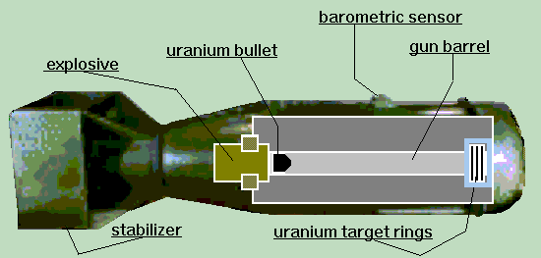

Little Boy (A-Bomb: gun barrel)

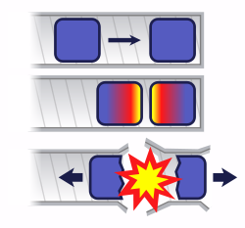 **approx. 13-18 kiloton explosion**

A subcritical mass of fissile material was shot down a track into a

stationary mass of fissile material. The combination made created a

supercritical mass and the explosion occurred …

This was how they timed it…. <http://en.wikipedia.org/wiki/Critical_mass>

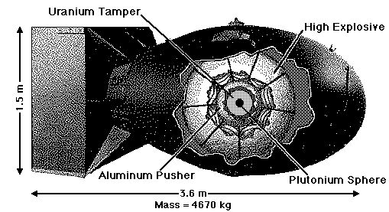

Fat Man (A-Bomb: Implosion)

**approx. 20-22 kiloton explosion**

<http://www.hibbing.tec.mn.us/programs/dept/chem/abomb/page_id_88783.html>

This was a shaped-charge implosion bomb. Robert Oppenheimer learned how to “shape charge”

into lenses. These lenses were chemical explosives which surrounded a sphere of highly

purified but only critical mass of plutonium metal. The chemical charges were detonated

simultaneously, creating a concussive force which exploded inwardly towards the sphere of Pu.

The force, collapsed or shrank the sphere to a volume, at which the mass per volume made the

sphere a supercritical mass, and the explosion occurred.

See: <http://en.wikipedia.org/wiki/Nuclear_weapon_yield> for comparisons

X) How do we get electricity from a nuclear power plant?

A) Nuclear Power plants used a CONTROLLED FISSION REACTION. Only about 3% of the

uranium is fissile. A nuclear power plant does NOT have enough uranium to explode, like an

atomic bomb….

B) Let’s look at other types of power plants …



Stored water (e.g. behind a dam or a running river) is allowed to pass over turbines which crank generators. These generators spin and produced electricity!

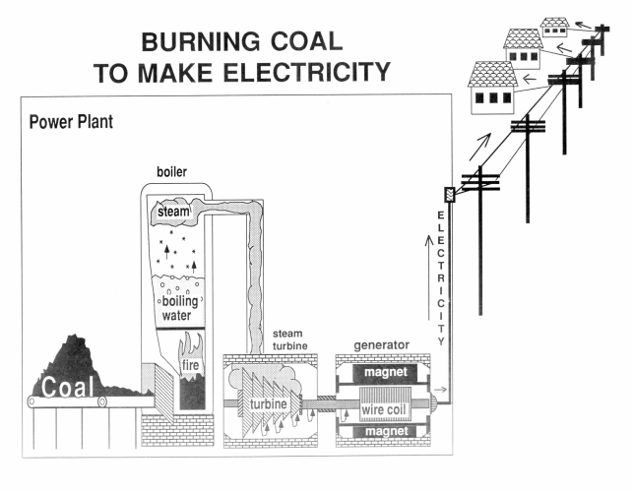

Coal is burned. The produced energy is allowed to boil water, which is, in turn, allowed to turn to steam. The steam is used to crank a turbine. The turbine cranks a generator which produces electricity…

C) The goal of ***any*** power plant is

⮷

To generate heat ⏩ to boil water

🡻 to create steam  to crank turbine generators

⭍

to make electricity



D) Nuclear Power Plant: fission based

1) Fuel: Uses pellets of uranium oxide, enriched to about 3% U-235.

2) Rate of reaction is controlled by: Control Rods of Boron and Cadmium

3) Fuel rods and Control rods are surrounded by water (or some other “moderator, used to

slow neutrons down sufficiently to create an effective fission)

4) Moderator/Coolant (often the same fluid … eg. Heavy water, molten sodium metal)

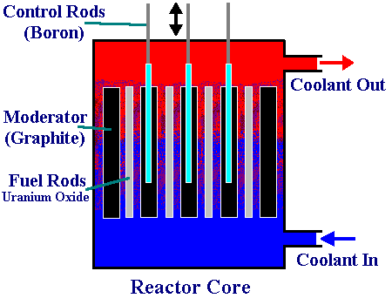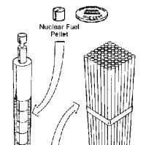

1) Fuel rods are bundled and placed between control rods of barium and/or cadmium.

2) Control rods can absorb neutrons and are used to regulate the rate of change.

3) When the control rods are pulled out, totally, fission is allowed to run at the highest level

4) When the control rods are inserted between the fuel rods, the change stops.

5) The moderator/coolant surrounds the fuel rods and control rods. Neutrons must pass through

this moderator on the way to other fissile matter. The moderator slows down the neutrons

for a more efficient fission. Fast neutrons may “bounce off” nuclei and not fission the

nucleus.

6) The energy produced is absorbed by the moderator/coolant and swept off to a heat exchanger.

Heat Exchanger



Notice that the core, has the fuel rods, control rods and moderator/coolant. The moderator/coolant fluid

becomes radioactive, **and insanely hot!** The moderator fluid is NOT allowed to leave the reactor core.

The energy of this heated fluid is transferred via a heat exchanger to fresh water. THIS FRESH water

is allowed to boil, to produce steam. The steam cranks a turbine generator, which produces electricity.

The difference between a nuclear power plant and a coal plant is at the simplest analysis, the source of

the energy used to boil water!

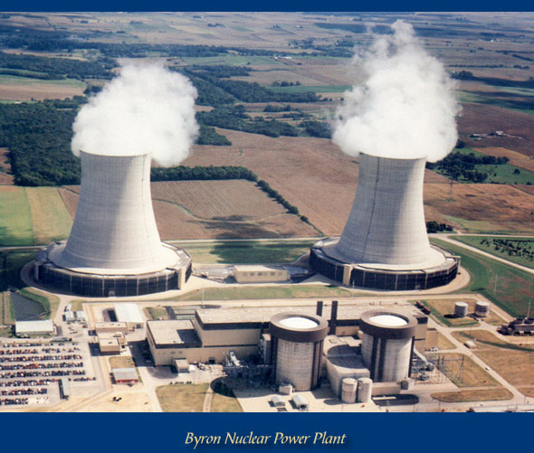

Summary: Containment Building (Houses the reactor core)

3 parts of the reactor core

|  |  |  |
| --- | --- | --- |
| Part | Function | Ex. |
| Fuel Rods | Holds UO2 pellets enriched to 3%  U-235 radioisotope | U-235 |
| Control Rods | Control the rate of reaction by absorbing neutrons | Ba, Cd,  Ag, In |
| Moderator/Coolant | Two functions: Slows fast moving neutrons and absorbs the heat of reaction | Water, Heavy Water, Na |

Cooling Tower (Not found

at all Nuclear Power Plants)

Hot water is pumped to the

top and allowed to trickle

down, cooling as it goes.

This water is then released

into the environment.

XI) NUCLEAR FUSION

A) Fusion: The combining of various light (as in "not heavy") nuclei into a larger and heavier nucleus.

***Thermonuclear***

B) Involves a mass defect: nuclear matter is merged, thus there will be a loss of mass and a

**liberation of energy due to the lost mass's conversion to that energy**.

1) eg) deuterium + tritium 🡪 helium-4 + neutron



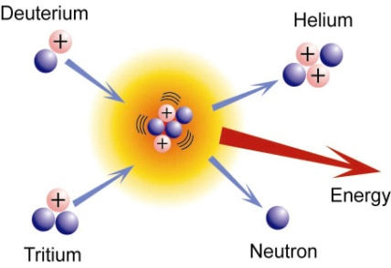 + → +

Or

Li + H → 2 He + energy

B + H → 3 He + energy

http://www.lancs.ac.uk/ug/hussainw/nuclear_fusion.htm

a) What is the "source" of this released energy? There is a mass defect, due to the

*merging of protons and neutrons into new nuclei … Whenever new nuclei are

produced some mass is converted into energy (mass defect) … That’s the bomb blast.

2) The initiation of a fusion reaction requires exceptionally high temperature & pressure.

**WHY?** A fusion reaction works by merging positive nuclei into a single, larger nucleus...

**\* positive nuclei of H1+ repel each other**

3) Occurs in the sun and other stars, Hydrogen-bomb (H-Bomb)

a) It is so difficult to get H+ to merge … it requires such high temperatures and pressure,

that in order to detonate a H-bomb, an atomic (fission) bomb must be detonated first.

b) On average the H-Bomb is 10 times more powerful than the atomic bomb.

4) We can NOT control fusion here on Earth ... as it is so difficult to control the merging of

H+ ions (essentially protons, due to their natural repulsions). Right now, we either get them

to combine … or not at all. But if we were able to control it ... then estimates suggest that

there is enough hydrogen in 1 km3 of water to produce enough energy via nuclear fusion, to

cover the USA’s energy needs for 100 to 300 years!

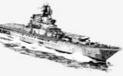

1 km

1km

1km

5) 2 possible technologies: TOKAMAK and Inertial Confinement Fusion (ICF)

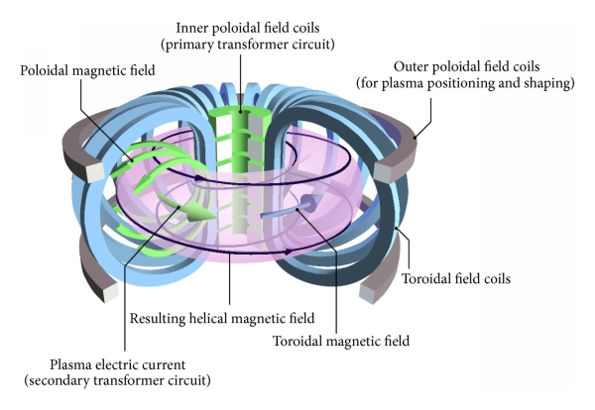

a) Tokamak:

<https://en.wikipedia.org/wiki/Tokamak>

A tokamak is a toroidal (doughnut-shaped) magnetic plasma confinement device, it’s a

leading candidate for producing magnetic fusion energy. It uses magnetic field to contain

H+ plasma field. The magnetic field strength is increased trying to fuse the H+

Tokamak is a Russian acronym for: "**t**oroidalnaya **k**amera s **m**agnitnoi **k**atushkoi"

(toroidal chamber with magnetic coil).

It was invented in the 1950s by Igor Yevgenyevich Tamm and Andrei Sakharov.

b) ICF: (inertial confinement fusion) Use of lasers to initiate the fusion reaction.

A small spherical glass pellet is filled with LiH … The pellet is so small, it can fit in the eye of

a needle! Using upwards of 50 to 70 lasers, the LiH is compressed to a very high density. The

collision rate then increases, and the fuel burns before it can disassemble (about 10 -11 seconds).

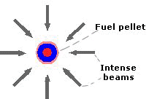 The fuel is only held together by its inertia.

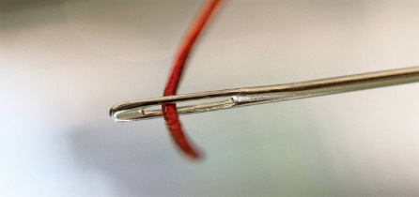

|  |
| --- |
| particle density ≅ 1026/cm3≅ 60 times the density of iron |

The pellet can be compressed using laser beams, ion beams or x-rays. If lasers are used, the

concept is called "laser fusion". If the lasers shine directly on the pellet, the target is called

"direct-drive".

The fuel density cannot be less than about 1026 particles/cm3 because one would then need

too large a volume of material to inertially confine and efficiently burn up the fuel. With the

increased volume, the explosion would be too large to confine. To maximize performance, most

of the fuel is kept cold, and only a central portion is heated to form a "spark plug" that then

ignites the rest of the fuel.  <http://other.nrl.navy.mil/LaserFusionEnergy/fuelconfinement.htm>