NAME________________________________ UNIT 3: PART 2: ORGANIC COMPOUNDS & POLARITY

I) There are two huge classifications of compounds: INORGANIC & ORGANIC.

A) Organic compounds are compounds of carbon, in which the carbon(s) is (are) the *central

atom(s), to which all other species are united chemically via (a) covalent bond(s). (There

are very few exceptions to this definition… SiC, diamonds, CO2 and CO)

BUT! ***Carbon as the central atom***, has little meaning for students without quantum mechanics.

so, we will use a somewhat more problematic definition (It has a few exceptions)

For our course, we will say that an organic compound is**\* any compound with C to C bonds or**

**C to H covalent bonds For exceptions, see:** "Chemical Issue".

**Generally, the absence of C to C or C to H bonds will identify a compound as *inorganic***

Chemical Issue:

Many times, we hear that organic substances must have carbon bonded to hydrogen... (-C—H) (think of your last biology course) However, there are problems with this definition, and really, all other definitions for organic compounds.

This reading lays out theses issues. NO SINGLE definition can be applied universally (there are always exceptions)

First, historically, organics are compounds, not **elements.** Pure solid carbon (diamond, nanotubes, and graphite

[found as pencil lead, golf club shafts]) is elemental. Thus, it’s not an organic *compound*! So far, so good ...

The above are elements with C to C bonds but are not compounds! Okay…. They’re not “organic compounds”.

Silicon carbide (SiC), carbon dioxide (CO2) & carbon monoxide (CO) are compounds with atoms of carbon, BUT

they ARE NOT considered to be organic compounds. There are no C-H bonds and there are no C-C.

**Still, so far so good.**

MC900055209[1]The molecule, CH4(g) is undeniably considered to be an organic substance (It has C – H bonds). But, [wait for it…..]

its derivative CCl4(l) **is *also* considered to be an organic compound**.

O O

║ ║

H-O—C — C—O-H

oxalic acid

Crap! ... "Houston, we have a problem"

Additionally, urea ([N](http://en.wikipedia.org/wiki/Nitrogen)[H](http://en.wikipedia.org/wiki/Hydrogen)2)2[C](http://en.wikipedia.org/wiki/Carbon)[O](http://en.wikipedia.org/wiki/Oxygen)) and oxalic acid H2C2O4 , are both considered to be organic

compounds! First, neither has any C- H bonds, And, worse, urea lacks **both** C – C bonds

O

||

C

H ─N N─H

| |

H H

urea

and C – H bonds!!! But it is historically an “organic compound” (**sigh**!)

Also, ketomalonic acid, (HO-(C=O)3-OH), and mellitic acid (C12H6O12) are both compounds

that NASA thinks might be *organic* compounds found in extraterrestrial soils (like the

thin soils of asteroids or of Mars). Neither has C – H bonds and ketomalonic acid

lacks both C – C and C – H …just like CCl4 and urea … **yet, another, sigh!**

So, let's say for OUR course, most organic compounds will have **C-C bonds or C-H bonds**

**represented in their structures,** with the substances immediately above, being exceptions,

to that rule and they are organic compounds (due to historic or functional reasons).

Also, as you probably know... biochemical organics (the ones found in living systems) will be made from

atoms of C, H, **and** O, N, S, Cl, Fe, Mg, Ca and a few more species ... very often... Can I go home now?

B) Every carbon atom in an organic molecule will have * 4 covalent bonds.

1) We can symbolize organic compounds with **molecular**, **condensed** & structural formulae

Study the diagram. The carbon atoms really form a jagged backbone, each carbon bonded to

another and then to hydrogen atoms to complete the need for 4 covalent bonds.

eg) H H H

| | | Molecular Formula= C3H8

H⎯C⎯C⎯C⎯ H

H H H

| | |

H⎯C⎯C⎯C⎯H

| | |

H H H

| | |

H H H

Condensed Formula = * CH3CH2CH3

Study the diagram. Every C atom has * 4 covalent bonds. Recall that each solid dash (⎯)

represents * 1 pair of shared e-.

eg) H H H H O Condensed Formula=

| | | | //

H⎯C⎯C⎯O⎯C⎯C⎯C⎯O⎯H Molecular Formula =

| | | |

H H H H

How many covalent bonds does the molecule represented above, have? * 18

eg) Study the diagram. The bonds between carbon atoms can be single bonds,

* double bonds (2 pair of shared e-) or even * triple bonds

H H H Condensed Formula =

| | |

H⎯C⎯C = C⎯H Molecular Formula =

|

H

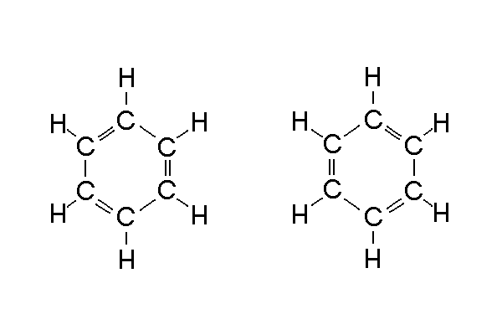

eg) Consider the structures:

which are often or

written as:

SPECIAL CHEMICAL APPLICATION: THEORY TO OUR LIVES

Take another 5 minutes please, to go to the next level… That level deals with how the *organization / orientation, or number of C to C covalent bonds affects the molecule, its chemistry, our lives.*

C) Saturated Organic Molecule versus ***UN***saturated Organic Molecule

1) * Saturated : A broad descriptive term, which tells you that every

the term "organic molecule" may apply to hydrocarbons and their derivatives

**Carbon to Carbon** bond is * a single covalent bond

a) if a * double bond or a * triple bond exist between any **pair of carbon**

**atoms** anywhere in the molecule, that molecule is considered to be * unsaturated.

H H H H H

| | | | |

H−C−C−C−C−C−H *This is an example of a C-C single bond*

| | | | |

H H H H H

H H H H O The bonds between C atoms are * single

| | | | // Even though there is the double bond between C and O

H−C−C−O−C−C−C−O−H this molecule is still classified as * saturated.

| | | |

H H H H

H H H Note the double bond between two of the carbon atoms | | | This molecule is considered to be * an **UNsaturated molecule**

H−C−C = C−H

|

H

**Question**: Which of one of these two structural formulae represents a **saturated** molecule?

H H H H O

| | | | //

a) H−C=C−C−H b) H−C−C−C−C−H

| | | | | |

H H H H H H

NOW, Have you ever heard the terms: ***Poly***unsaturated Fat, ***Mono***unsaturated Fat, & Hydrogenated Oils?

Many double/triple bonds 2) **Relevance to us:** Saturated fats (as opposed to unsaturated fats) tend to lead to the

development of cholesterol.

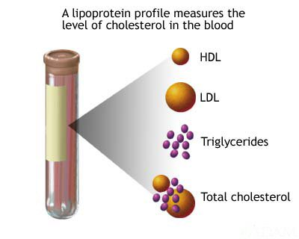

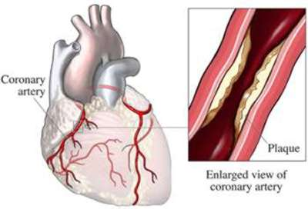

**Relevance To Us: Cholesterol**

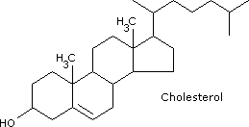

As cholesterol is not water-soluble it must bind

to special proteins before it can be carried in the bloodstream, known as apoproteins. Once coated they form a package called lipoproteins,

there are 2 main types of lipoproteins:

**Low density lipoproteins** (LDL), commonly known as bad cholesterol. LDL is the major cholesterol carrier in the blood. If there is too much LDL in the blood it can build up on artery walls. A high level of LDL cholesterol may give you an increased risk of coronary [heart disease](http://www.homehealth-uk.com/medical/heartdisease.htm).

**High density lipoproteins** (HDL), is commonly known, as good cholesterol. HDL is actually good for maintaining the health of the heart and preventing the narrowing of the arteries (atherosclerosis) because it appears to carry cholesterol away from the arteries and back to the liver for disposal.

This is why the ratio between LDL and HDL cholesterol is important. Usually the body maintains a balance of cholesterol, making more if it needs it and getting rid of any excess. But sometimes this balance goes wrong. LDL levels can be lowered by eating a low fat diet and HDL levels can be raised by exercising.

[|](http://www.homehealth-uk.com/index.html?f=body|fr=http://www.homehealth-uk.com/medical/cholesterol.htm|r)

Check Out: <https://www.health.harvard.edu/staying-healthy/the-truth-about-fats-bad-and-good>

For a comparison of various lipids check out: <http://www.elmhurst.edu/~chm/vchembook/556steroids.html> and <http://biology-pages.info/F/Fats.html>

Triglycerides: *a type of lipid (fat) found in your blood*

**A Little Background:**

As with most issues, there are good things and bad things about fat. The fatty acids of fats are good bio-chemicals! They used to build cells membranes, store energy, and are used *like hormones*, as signaling chemicals aiding in cell function. <http://lpi.oregonstate.edu/ss08/fat.html>

Normally, for us to utilize fat in food, complex lipids must first be hydrolyzed into smaller fatty acids, in the small intestine.

The released fatty acids are absorbed by intestinal cells where they are converted to triglycerides (glycerol bonded to various fatty acids) for packaging into lipoprotein particles called chylomicrons, [**ki-low-my-krahns**] which circulate in the blood.

Hence, chylomicrons (often rich with triglycerides), are vehicles for the delivery of fat to cells, via the bloodstream.

Enzymes, like lipoprotein lipase, on the surface of cells, degrade chylomicron lipids so that fatty acids can enter cells. Once in cells, fatty acids are processed through various metabolic pathways, such as assembly into triglycerides for storage, assimilation into phospholipids for membrane synthesis, or oxidation in the mitochondria for energy production. <http://lpi.oregonstate.edu/ss08/fat.html>

**Triglycerides**

Triglycerides are one type of lipid (fat) found in your blood. There are two main sources of triglycerides: the diet and the liver. As mentioned, previously, triglycerides are essentially a group of biochemicals produced by bonding glycerol to various fatty acids <http://lpi.oregonstate.edu/fw08/triglyceride.html>

When you eat, your body converts any calories it doesn't need to use right away, into *dietary* triglycerides. The triglycerides are stored in your fat cells (adipose tissue). Later, hormones release triglycerides for energy required by muscle, between meals. <http://www.mayoclinic.com/health/triglycerides/CL00015>

The liver also produces triglycerides from both fat and carbohydrate. Hepatic (liver) triglycerides are then packaged into very low-density lipoproteins (VLDL) and secreted into the blood for delivery to various tissues for the production of energy. Hence, VLDL are the lipoprotein particles formed to transport endogenously derived triglycerides to tissues. <http://lpi.oregonstate.edu/fw08/triglyceride.html>

[Although triglycerides are energy rich, and used to store energy], chronically elevated triglyceride levels in the blood are associated with metabolic syndrome, diabetes, and heart disease. Obesity, diabetes, a high-fat diet, and various genetic conditions can cause elevated triglycerides. Food intake in excess of the body's need for energy exacerbates fat deposition in adipose and muscle tissue, with possible detrimental health consequences. <http://lpi.oregonstate.edu/fw08/triglyceride.html>

Sources:

Jump, Donald B, WHAT'S GOOD ABOUT DIETARY FAT? <http://lpi.oregonstate.edu/ss08/fat.html> (search author’s name)

Moreau, Régis, TRIGLYCERIDE-LOWERING PROPERTIES OF LIPOIC ACID <http://lpi.oregonstate.edu/fw08/triglyceride.html> (search

author’s name)

Mayo Clinic Staff, Triglycerides: Why do they matter?<http://www.mayoclinic.com/health/triglycerides/CL00015>

Now, Back To Our Regularly Scheduled Program….

TRY THIS: Complete the table for practice on interpreting formulae

|  |  |  |
| --- | --- | --- |
| Structural Formula | Condensed Formula | Molecular Formula  As a rule, hydrocarbon portions are grouped together, and functional groups are listed separately. |
| H H H H  | | | |  H⎯C⎯C⎯C⎯C⎯H  | | | |  H H H H | *CH3CH2CH2CH3 or  *CH3(CH2)2CH3 | * C4H10 |
| H H H  | | |  H⎯ C⎯C⎯C⎯ **O**⎯H  | | |  H H H | *CH3CH2CH2OH | *C3H7OH |
| H H H  | | |  H⎯ C⎯C⎯C⎯ **N**⎯H  | | | |  H H H H | *CH3CH2CH2NH2 | *C3H7NH2 |
| H H H H  | | | |  H⎯C⎯C = C⎯C⎯H  | |  H H | *CH3CHCHCH3 | *C4H8 |
| COOH | C6H6COOH | * C7H7O2 |

D) Nomenclature for some “simple” organic compounds

1) Hydrocarbons: Organic compounds that are made from ONLY **C and H**

a) For the simplest hydrocarbons: (aliphatic or straight carbon chain)

Every name has a prefix and a suffix. The prefix depends upon the *# of carbon atoms o

and the suffix depends upon * the bonds between the carbon atoms

(single, double, triple)

|  |  |  |  |  |  |  |
| --- | --- | --- | --- | --- | --- | --- |
|  | | **The Hydrocarbons** | | | | |
|  |  | | Examples | | | | |
| Family | General  Formula | | Formula | Name | Structure  H H H H  | | | |  H—C—C—C—C—H  | | | |  H H H H | Other Views | |
| alkane | CnH2n+2 | | C4H10 | butane |  |  | |
| alkene | CnH2n | | C4H8 | 1-butene | H H  | |  H—C—C—C C—H  | | | |  H H H H |  | |
| alkyne | CnH2n-2 | | C4H6 | 1-butyne | H H  | |  H—C—C—C C—H  | |  H H | CH3CH2CCH | |
| arene  (aromatic  hydrocarbon)  note: the term *aromatic* refers to a closed ring with C or N with alternating double bonds | CnH2n-6 | | C6H6 | benzene |  |  | |
|  | | where "n" equals the number of carbons in the longest (parent) chain | | | | | |

|  |  |
| --- | --- |
| **Organic Prefixes** | |
| **# of carbons** | **Prefix** |
| 1 | meth |
| 2 | eth |
| 3 | prop  pron: **prōp** |
| 4 | but  (pron like **beaut***-y*) |
| 5 | pent |
| 6 | hex |
| 7 | hept |
| 8 | oct |
| 9 | non |
| 10 | dec |
| 12 | dodec  (laur-*yl*) |
| 16 | Hexadec  (cet-*yl* or myrist-*ic*) |
| 18 | octadec (stear-*yl*) |
| 20 | eicos (arachid-*ic*) |

Name the following compounds

C3H8 ______________________ (fuel for your gas grill)

C4H10______________________ (fuel of a BIC lighter)

C8H18 ______________________ (may be found in gasoline blends)

CH4 ____________________ (natural gas used in some furnaces)

QUESTIONS ON HYDROCARBONS :

___1) Arithmetically speaking, the difference in formula between an alkane with three carbons, and one with four carbons

is that the latter molecule has

a) 1 more carbon and 1 more hydrogen c) 1 more carbon and 2 more hydrogen

b) 2 more carbons and 2 more hydrogen d) 2 more carbons and 1 more hydrogen

___2) Which pair represents two alkanes?

a) CH4 & C6H14 b) CH4 & C6H12 c) CH4 & C6H10 d) CH4 & C6H6

___3) Which pair represents two alk**Y**nes?

a) C3H4 & C6H14 b) C4H6 & C6H10 c) C2H4 & C6H12 d) C2H4 & C6H6

___4) Which pair represents two alk**E**nes?

a) C3H4 & C6H14 b) C4H6 & C6H10 c) C2H4 & C6H12 d) C2H4 & C6H6

___5) Which compound is a member of the same family of hydrocarbon as C7H12?

a) C7H8 b) C9H18 c) CH4 d) C5H8

___6) Which compound has a double bond between carbons?

a) C7H8 b) C9H18 c) CH4 d) C5H8

7) Which will have more hydrogen, a five carbon alkEne or a 6 carbon alkYne? ____________________

8) Name: C6H14 __________________________

9) Name: C2H4 __________________________

10) Name: C5H12 __________________________

11) Name: CH3CH2CH2CH3 ____________________________

12) Draw the structural formula for **C3H8**

Answers: 1) c 2) a 3) b 4) c 5) d 6) b 7) neither one: they have the same number of hydrogen atoms 8) hexane 9) ethene 10) pentane

11) butane 12) Start by writing down 3 carbons. Connect them with bonds (―). Add 8 hydrogen so each C has only 4 bonds.

2) Other organic compounds (It's not all about carbon and hydrogen sometimes...)

Most organic compounds have special clusters of atoms called **FUNCTIONAL GROUPS**

These functional groups give the compounds special non-hydrocarbon properties.

**Organic Compounds with Functional Groups**

|  |  |  |  |  |
| --- | --- | --- | --- | --- |
| Class | Description | Examples of molecular or condensed formula | a Example / Structure | b Example / Structure |
| Alcohol  (Mono-  hydroxy) | R-OH  1 (O-H) group bonded to a carbon. Soluble in water (polar molecule) | a C3H7OH  b C4H9OH | a1-propanol  H H H  | | |  H—C—C—C—O-H  | | |  H H H | b 2-butanol  H H H H  | | | |  H—C—C—C—C—H  | | | |  H OH H H |
| Alcohol  (Glycol or Dihydroxy) | 2 O-H groups (or OH groups ) bonded to carbon. Soluble in water (polar molecule) | a C2H4(OH)2  b C3H6(OH)2 | a1,2-ethanediol (ethylene glycol)  H H  | |  H—C—C—H  | |  OH OH | b1,2-propanediol (propylene glycol)  H H H  | | |  H—C—C—C—H  | | |  H O-H O-H |
| Ester | O  ||  R—O—C—R'  The product of an alcohol & organic acid reaction. | a CH3OOCCH3  b C2H5OOCC2H5 | a methyl ethanoate  H O H  | || |  H—C—O—C—C—H  | |  H H | b ethyl propanoate  H H O H H  | | || | |  H—C— C—O—C—C—C—H  | | | |  H H H H |
| Ketone | O  ||  R— C—R**'**  A **carbonyl group** on an "interior" or non-terminal carbon | a C3H6O  b C6H12O | a 2-propanone (acetone)  H O H  | || |  H—C—C—C—H  | |  H H | b 3-hexanone  H H H O H H  | | | || | |  H—C—C—C—C—C—C—H  | | | | |  H H H H H |
| Carboxylic  Acid  (the most common form of organic acid) | O  ||  R—C—O-H  A **carboxyl group**  (COOH) bonded to a carbon. | a CH3COOH  b C2H5COOH | a ethanoic acid (acetic acid)  H O  | ||  H—C—C—O—H  |  H | b propanoic acid    H H O  | | ||  H—C—C—C—O—H  | |  H H |
| Amine  (simple) | R⎯N⎯H  |  H  An organic derivative of NH3 (at least one H is replaced with an organic group. A weak base (B-L) | a C3H7NH2  b C6H5NH2 | a 1-propanamine (1-propylamine)  H H H  | | |  H⎯C⎯C⎯C⎯N⎯H  | | | |  H H H H | b aniline    ••  N⎯H  |  H |
| Halide  (Halocarbon) | R-X  Halogen(s) substituted onto a hydrocarbon, by removing hydrogen(s) | a C3H7Br  b C3H6F2 | a1-bromopropane    **Br** H H  | | |  H—C—C—C—H  | | |  H H H | b1,2-difluoropropane  H H **F**  | | |  H—C—C—C—H  | | |  H **F**  H |

TRY THIS: Give the correct class of the following compounds

H H H H H

| | | | |

H―C―C―C―C―C―H

| | | | |

H OH H H H

Class : ________________

H H H H

| | | |

H―C―C―C―C―**O-H**

| | | |

H H H H

Class: ________________

1) 6)

H H H H H

| | | | |

H―C―C―C―C―C―H

| | | | |

H H H H H

Class: __________________

H H H H

| | | |

H―C―C―C―C―**Br**

| | | |

H H H H

Class: __________________

2) 7)

H H H H H **O**

| | | | | **//**

H―C―C―C―C―C―**C―O-H**

| | | | |

H H H H H

Class: __________________

H H H H **O**

| | | | **//**

H―C―C―C―C―**C―O-H**

| | | |

H H H H

Class: __________________

3) 8)

H H H

| | |

H―C―C―C―C―H

| || | |

H O H H

Class: __________________

H H H H **O** H H

| | | | **||** | |

H―C―C―C―C―**C**―C―C―H

| | | | | |

H H H H H H

Class: ___________________

4) 9)

H H H

| | |

H―CC―C―C―H

| | |

H H H

Class: _________________

5)

**O**

**//**

H―**C―O-H**

Class: __________________

10)

Answers

1) alcohol 1-butanol (every alcohol must have a number in the name to describe the position of the Carbon atom with the –OH functional group)

2) halide 1-bromobutane The number emphasizes which C has the Bromine (bromo) group

3) carboxylic (organic) acid pentanoic acid Since the COOH groups are terminal (always on an "end"), no number is used in the name.

4) ketone 3-heptan**one**  This is a ketone. You need to have the numbered Carbon atom . Begin to count from the end nearest the functional group (in this case, then, begin counting from the right)

5) carboxiylic acid methanoic acid (also called formic acid .... The Genus of ants FORMICA was named for this chemical The ants inject it with every bite ...hence the FIRE ANTS are of the genus Formica!!!)

6) alcohol 2-pentanol 7) alkane pentane 8) carboxylic acid hexanoic acid 9) ketone 2-butanone 10) alkene 1- butene

II) Summary: Compound: an electrically neutral structure made of 2 or more different elements that are

bonded chemically to each other, due to an attraction of opposite charges or shared

electrons.

2 or more different bonded elements (s,l,g)

recognition:

occur in specific ratios between (subscripts)

COMPOUNDS can be decomposed into simpler substances

2 sub-divisions

Inorganic Compounds & Organic Compounds

may be further classified as: vast number classified as:

or

Ionic Compounds Covalent Compounds Covalent Compounds

***has*** (A.K.A. molecules or molecular compounds) (A.K.A. molecules or molecular compounds)

ionic bonding

covalent bonding covalent bonding

***made with***  ***made with*** ***but different from inorganics due to***

generally m+ nm-

due to a complete mostly due to a sharing carbon to carbon bonds &/or

transfer of valence e- of valence e- between. carbon to hydrogen covalent bonds

nonmetals

the sharing may be equal or

e.g) NaF unequal. Electronegativity e.g) all hydrocarbons

Fe2O3 differences are important here esters, alcohols,

CaCl2 e.g) H2S ketones, .....

ICl

SO3

cations + NI3

anions -

further described as

ions in water = electrolytes

**Nonpolar Molecules**  **Polar Molecules (dipoles)**

have have

even shape uneven shape to the molecule or an uneven charge

distribution

across the molecule

poorly soluble in water soluble in water

oils, waxes, various gases many simple carbohydrates,

many alcohols AND most acids

Let the term "polar" = different or difference

nonpolar = same (not different)

•

•

•

•

•

•

••

••

••

O = O H⎯O

|

H

H

|

•

•

•

•

••

••

H ⎯C⎯O⎯H O = C = O

|   
 H

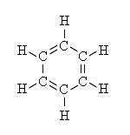 *********************************

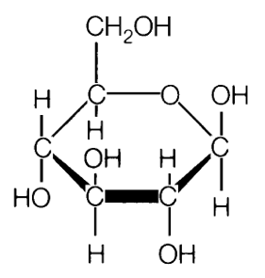

A B

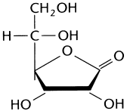

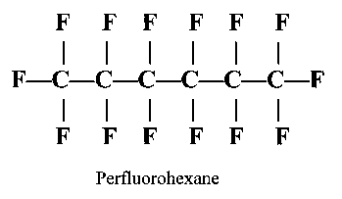

C D

H H H

| | |

H—C—C—C—OH

| | |

H H H

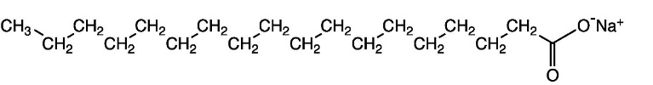

E F

H H H

| | |

H—C—C—C—H

| | |

H H H

H O

| ||

H—C—C—O—H

|

H

G H

C) Application of molecular polarity

1) LIKE DISSOLVES LIKE * Polar substances dissolve in other polar substances and

nonpolar substances dissolve in other nonpolar substances.

e.g.) Stop with the turpentine on your skin ... Go for Berio Olive Oil!!!

Checkout: Stainarator Infomercial <https://www.youtube.com/watch?v=W-4Sa1S8EY8>

Alton Brown **Good Eats S2E11P2: Pantry Raid II: Seeing Red** at around 7:40

<http://www.youtube.com/watch?v=xJ0-iFAzYvg>

|  |  |
| --- | --- |
| MATTER / MIXUTRES MADE WITH POLAR  MOLECULES | MATTER / MIXTURES  MADE WITH NONPOLAR  MOLECULES |
| WATER | OIL / GREASE / FAT |
| * Alcohol (C-OH),  Ethanol, Methanol, Glycols | * Methane, Propane, Butane |
| * Ammonia | * Oxygen |
|  | * Carbon Dioxide |
|  | * Carbon Tetrachloride |
|  |  |

Using: Like Dissolves Like ... Other applications

2) Hey Global Thinkers! ... *From NGEO "Dawn of the Ocean" 2 Sept 2010* ....

Scientists at the University of Kiel, plan to take nonpolar CO2(g) molecules from the atmosphere and

pump them into areas of the sea bed that contain nonpolar methane hydrate stores (CH4) (also called

methane clathrates). Methane molecules become trapped in the frozen cages of water-ice (recall, as

<http://www.noc.soton.ac.uk/gg/IPY/background.html> water expands as it freezes.) This occurs as low temperature and fairly

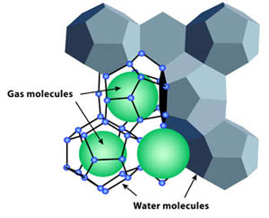 high pressure ...There are significant deep oceanic deposits in the Gas

Hydrate Stability Zone (GHSZ)

Anyway, by pumping CO2 into the area of clathrate formation, in theory the

nonpolar carbon dioxide molecules will dissolve the nonpolar methane, and

replace the methane molecules.

The methane will be pumped up and out, condensed and shipped for use as the fossil fuel that it is....

Thus, the scientists are trying to integrate issues surrounding global warming with the greater extraction

and use of fossil fuels . Any thoughts? What must be considered? Would you buy stock in a company?

Reading further: Go To: <https://www.llnl.gov/str/Durham.html>

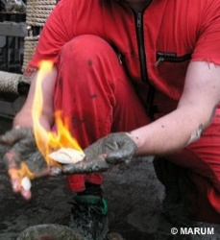 <http://marine.usgs.gov/fact-sheets/gas-hydrates/title.html>

Picture: <http://www.noc.soton.ac.uk/gg/IPY/background.html>

In terms of concentration one liter of methane clathrate solid would contain, on average,

168 Liters of methane gas at STP.

Calculation: The average methane clathrate hydrate composition is **1 mole of methane for every 5.75 moles of water.** The observed density is around 0.9 g/cm3. For one mole of methane, which has a molar mass of about 16.04 g, we have 5.75 moles of water, with a molar mass of about 18.02 g, so together for each mole of methane the clathrate complex has a mass of 16.04 g + 5.75 × 18.02 g = 119.65 g. The percent composition of methane, therefore, is equal to 16.04 g / 119.65 g = 0.134.

The density is around 0.9 g/cm3, so one liter of methane clathrate has a mass of around 0.9 kg, and the mass of the methane contained therein is then about 0.134 × 0.9 kg = 0.1206 kg. At a density as a gas of 0.717 kg/m3 at 0 °C, that means a volume of 0.1206 / 0.717 m3 = 0.168 m3 = 168 L. <http://en.wikipedia.org/wiki/Methane_clathrate#cite_note-5>

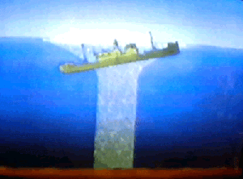 .... And that's not all... Some folks have hypothesized that the disappearances of ships and planes in the Bermuda Triangle, may be due to the destabilization of methane hydrates .... releasing huge amounts of methane gas, that lower the density of water so much (ships sink), and of air so much (planes can't stay aloft), that they are sent to the bottom of the sea....

<http://www.bermuda-triangle.org/html/methane_hydrates.html>

Using: Like Dissolves Like ... ONE MORE TIME!!!!

3) Okay ya gotta go out and get the movie The Abyss. It is a typical boy meets girl, boy

loses girl, boy joins a deep ocean expedition, where he meets up with girl... Mayhem

ensues and it's all about realizing one's heart's desire ....

It's crap .... but it's really cool crap ...because it is going to introduce you to a real material,

broadly classified as **a perfluorocarbon (purr-flur-oh-car-bon)**.

It is used to enable seriously deep water work, at depths where the pressure would crush the

lungs of the diver. The diver breaths in a nonpolar perfluorocarbon, saturated with dioxygen

gas ... and this is taken right into the lungs ...

See, the nonpolar (but very liquid) perfluorocarbon can dissolved nonpolar dioxygen!

Like dissolves Like, yeah baby....

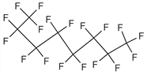

A classic perfluorocarbon is: You can guess that it began

a hydrocarbon, but all of the

hydrogen have been

substituted with fluorine.

<http://www.medicinescomplete.com/mc/martindale/current/images/c307-34-6.gif>

With this... we are beginning to produce "synthetic bloods" that will allow surgery patients

a less stressful surgery ....

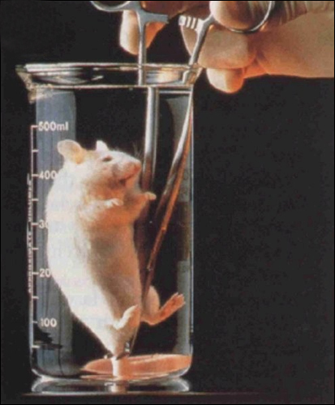 Oh yeah, check out the picture:

<http://www.cracked.com/article_17476_7-man-made-substances-that-laugh-in-face-physics.htm>

Know It: Like Dissolves Like....

Checkout: <https://www.youtube.com/watch?v=9MdlyM7w8PM> (Warning … a little difficult to watch,

from the movie, The Abyss)

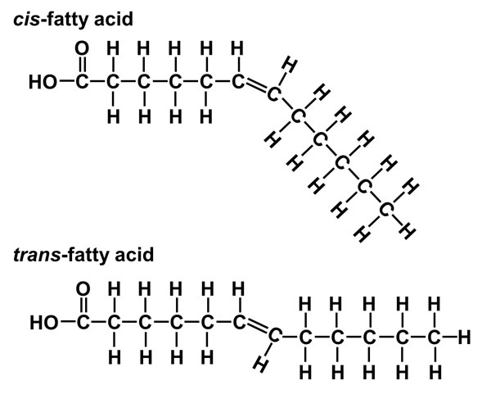

<https://dlc.dcccd.edu/images/biology/lesson3/cis_and_trans_fatty_acids.jpg>

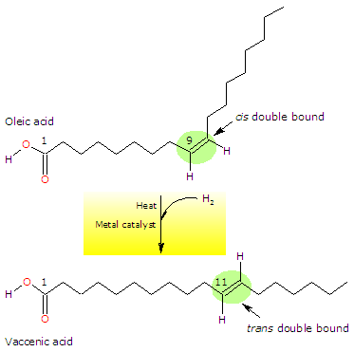

<https://www.tuscany-diet.net/wp-content/uploads/2017/09/Hydrogenation-process-of-oleic-acid.gif>