NAME____________________________________ NOTES: UNIT 2 ATOMIC STRUCTURE (PART 1) &

**ELECTRON CONFIGURATION (PART 2)**

**You need know these ideas about Atomic Theory:**

⮊ the role of valence electrons in reaction chemistry (part 2)

⮊ the commonality of reactions between family members of the periodic table (part 2)

⮊ the four basic categories of elements (part 2)

⮊ that the ion(s) of an element behave differently than the atom of the element

⮊ metal atoms are oxidized, and nonmetal atoms tend to be reduced in a reaction when reacted against a metal

⮊ the production of light energy (part 2)

⮊ the interpretation of a ground state configuration and excited state configuration (part 2)

**Part 2: Electron Configuration (Using the Bohr Model of the Atom):**

I ) Electron Configuration: We believe that electrons are ordered from low levels of energy to

higher levels of energy, which correspond statistically to probable locations of the

electrons from the nucleus.

A) According to Bohr:

a) electrons are organized outside of and around the nucleus

b) electrons are found at specific distances from the nucleus. These distances are

called energy shells (K – Q) or principal energy levels (1 – 7). (vocabulary term!!!)

j0237628 c) * there are 7 principal energy levels, some with electrons of a quantized energy

Picture it!

d) electrons nearest the nucleus are lowest in energy. The energy of electrons

* increases as their position from the nucleus increases.

(potential energy argument)

e) Ground State = * The electrons arranged in the lowest possible energy levels

f) the configuration found on your periodic table

3Li 4Be 5B 6C 7N 8O 9F 10Ne

11Na 12Mg 13Al 14Si 15P 16S 17Cl 18Ar

e- config. animation: [http://web.visionlearning.com/custom/chemistry/animations/CHE1.3-an-animations.shtml](%20http:/web.visionlearning.com/custom/chemistry/animations/CHE1.3-an-animations.shtml) or <http://tinyurl.com/yvqz8b>

II) What Do We Mean By Light?

**There is a connection between light and matter, in terms of how they behave.**

With the work of scientists such as Albert Einstein and Prince Louis de Broglie, it is fairly

common now, to consider energy and matter to have both wave-like properties and particle-like

properties.

Einstein called a light particle, **a photon.** A photon comes in little discrete packages of energy

called **quanta**. A **quantum** of energy is the amount of energy required to move an electron from

one energy level to another energy level … The electron’s energy is said to be quantized.

Two terms become important: Wavelength and Frequency

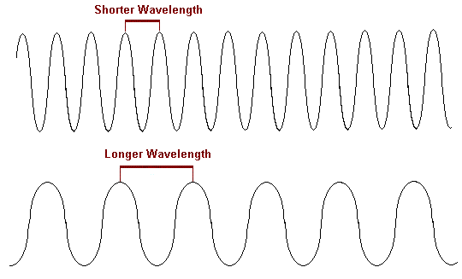

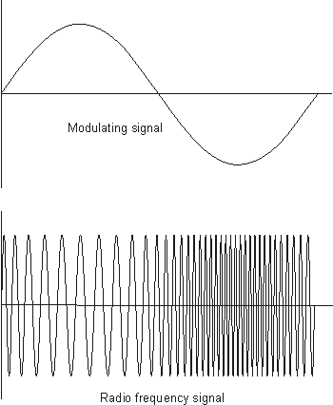

<http://www.qrg.northwestern.edu/projects/vss/docs/Communications/1-what-is-wavelength.html>

http://www.electronics-radio.com/articles/radio/modulation/frequency_modulation/fm.php

A) Excited State: * When the electrons of an atom absorb certain amounts of energy,

the inner electrons may move temporarily to higher energy levels. When the electron

returns to “normal”, the absorbed energy is often released as wavelengths of light.

i) e.g.) When the ground state 2-8-1 then an excited state could be __________

If the ground state is 2-8, then an excited state could be __________

1) The key to understanding why this is of any importance is due to the fact that the electrons

raised to a higher energy level ….. ***temporarily***. This means… what goes “up”, most come

back down …. and when these excited electrons come back down. *Let there be light!*

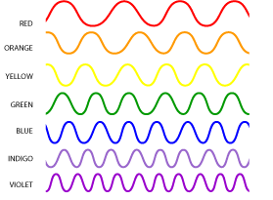

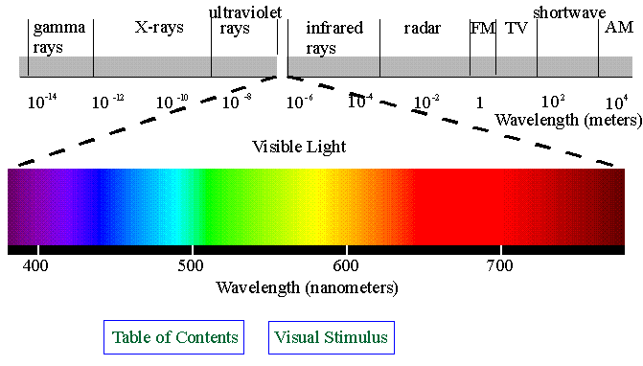

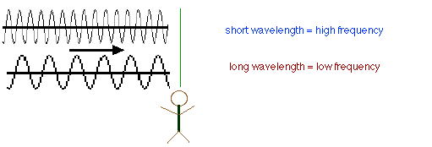

<http://science.hq.nasa.gov/kids/imagers/ems/visible.html>

http://www.uccs.edu/~tchriste/courses/PES100/100lectures/radio.html

Take Home Message for the Everyday student ….

**Different wavelengths of light energy, * give us our different colors of light**

EXCITATION AND RETURN TO GROUND STATE….AND THE RELEASE OF VISI BLE LIGHT ENERGY

e

e

e

1

2

e

e

An atom in the ground state

An e- absorbs energy from

an outside source

e

e

3

The absorbed energy pushes the e- farther away from

the nucleus. The e- is pushed to a higher energy level

The e- is “excited”. That is; the potential energy increases

e

e

4

The excited e- is unable to maintain its

excited state, in the absence of the outside

j0118347

energy source. The e- returns (falls back)

to its original energy level. This drop

brings the e- closer to the nucleus. The

potential energy decreases and the change in

energy (the lost energy) is released in a frequency

we can see (visible (colored) light)

Check out: <https://www.physicsclassroom.com/class/light/Lesson-2/Color-Addition>

<https://www.physicsclassroom.com/class/light/Lesson-2/Color-Subtraction>

Check out: <https://www.compoundchem.com/2014/09/11/autumnleaves/>

**Here is a neat application …Why is water “blue”?**

## Light attenuation in water

Shortwave radiation emitted from the sun wavelengths in the visible spectrum of light that range from 360 nm (violet) to 750 nm (red). When the sun’s radiation reaches the sea-surface, the shortwave radiation is attenuated by the water, and the intensity of light decreases exponentially with water depth. The intensity of light at depth can be calculated using the Beer-Lambert Law.

In clear open waters, visible light is absorbed at the longest wavelengths first. Thus, red, orange, and yellow wavelengths are absorbed at higher water depths, and blue and violet wavelengths reach the deepest in the water column. Because the blue and violet wavelengths are absorbed last compared to the other wavelengths, open ocean waters appear deep-blue to the eye.

In near-shore (coastal) waters, sea water contains more phytoplankton than the very clear central ocean waters. Chlorophyll-a pigments in the phytoplankton absorb light, and the plants themselves scatter light, making coastal waters less clear than open waters. Chlorophyll-a, absorbs light most strongly in the shortest wavelengths (blue and violet) of the visible spectrum. In near-shore waters where there are high concentrations of phytoplankton, the green wavelength reaches the deepest in the water column and the color of water to an observer appears green-blue or green.

<http://en.wikipedia.org/wiki/Attenuation>