NAME _______________________________ EVERYDAY CHEM: **UNIT 1 (P2)** ***MATTER*** & ENERGY

I-V) See pages 1-17

VI) **What is a chemical reaction?** We can describe a chemical reaction as any type of reaction in which

*new bonds are made (in the products)

*and these new bonds result in new solids, liquids or gases NOT found in the original reactants.

A) A bond is a relatively permanent rearrangement of the chemical species. It is made when electrons

of one species is attracted to the nucleus of another chemical species.

B) Not everything which happens to matter is a **chemical reaction**. A **chemical reaction** must include

the \***making of NEW bonds**. These new bonds result in the re-arrangement

of the ions or atoms, due to *changes in the electron clouds of those ions or atoms.

1) Classically, the greater the loss in enthalpy (heat content of the chemicals) and the increase

in entropy (the dispersion of energy among the chemical species), the more spontaneous the

chemical reaction.

a) Compounds in the gas phase exhibit greater entropy than in their solid phase.

b) Lowering enthalpy and increasing entropy = Big Idea 4 (a later topic…)

C) I differentiate between chemical reactions and what we might term, physical changes.

1) Physical changes include mixing, dissolving and phase changes (such as: melting, boiling,

condensing, freezing, sublimation, deposition)

2) Physical changes do NOT involve any type of new bonds or changes in the electron clouds.

D) Chemical reactions may involve physical changes (liquid water may become vaporized) … but

physical changes do not involve chemical reactions (no changes in the electron clouds).

E) Where I think things get confused is that chemical reactions can end up producing physical mixtures

as they are producing new chemical bonds.

One more time….

***NOT EVERYTHING THAT HAPPENS IS A CHEMICAL REACTION, but many***

***chemical reactions may involve a physical change in the matter. e.g. forming an (aq) and a new solid...***

2 ways to determine when a chemical reaction has occurred

On A Test In Your Life and in Lab

When there’s a re-arrangement of at least **2** of the 5 visual cues

element symbols so that new when there is a bold color change

(not pre-existing) substances are produced. when a new solid (precipitate) is produced

when a new gas is produced (fizzing, bubbles)

when a new liquid is produced (hard to tell when this happens)

when energy is absorbed or released (found in most interactions)

**TAKE HOME MESSAGE**: Bond Breaking (alone) does NOT mean a chemical reaction has occurred.

A chemical reaction occurs only when * new bonds are made (When bonds are just broken ...

it is not a chemical reaction … it could imply melting or dissolving in water, for example). A chemical

property involves the activity (loss / gain or sharing) of electrons.

F) Take a look at the chart: There are multiple visual clues that a chemical change has occurred.

1) In lab, or in demos you have seen the production of precipitates and gases. You have seen

bold color changes and clearly you have heated materials & or noted energy being released.

2) On a test, you want to look for the rearrangement of the element symbols. This is a clue.

a) For instance, look at the gas burning in a Bunsen burner, producing a flame.

CH4(g) + 2 O2(g) 🡪 2 H2O(g) + CO2(g) + 890 kJ

Notice that the carbon is bonded to hydrogen, on the reactant side, but carbon

is bonded to oxygen on the product side. This is a chemical reaction, due to

new bonds being made. The rearrangement of the symbols helps to visualize new

bonding.

Note that oxygen is bonded to another oxygen on the reactant side but on

the product side, oxygen atoms are bonded to hydrogen and to carbon. Again,

new bonds are made. This is a chemical reaction.

Or: Notice that 2 brand new gases, not found on the reactant side are produced,

and energy is evolved (the 890 kJ)

Here is a visualization of the chemical reaction:

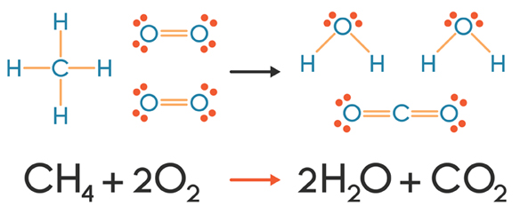CH4(g) + 2 O2(g) 🡪 2 H2O(g) + CO2(g) + 890 kJ

<https://www.learner.org/courses/chemistry/text/text.html?dis=U&num=Ym5WdElUQS9OeW89&sec=Ym5WdElUQS9OaW89>

Do you connect the changes in potential energy from the reactants to the products,

as the released heat and flame?

Let’s get started with a GREAT visual … This is fun… It is a demonstration I would do in class … just not at this scale! It is a **chemical reaction**. It is the rapid decomposition of a mixture of 30% Hydrogen peroxide into water, and oxygen gas (or dioxygen). It releases a great deal of energy. We will use it as our first model for the discussion of chemical reaction vs. physical change.

**catalyst**

**2 H2O2(aq) 🡪 2 H2O(ℓ) + O2(g) + 196.15kJ**

1 reactant product product product

Click on, turn up the Volume: <https://www.youtube.com/watch?v=XXn4fP3CnJg> (begin at 7 min)

Mixture: 35% Hydrogen Peroxide, Dawn Dishwashing Detergent, Potassium Iodide (KI) as a catalyst.

The catalyst is not consumed in the reaction … it simply acts like a matchmaker and speeds the reaction along.

This thing becomes dangerously hot! It is highly exothermic! Look at the steam produced! But it is so cool!

**Enzymes** are biochemical catalysts. They are not consumed in reactions but re-used repeatedly. *Catalase* is such a catalyst (enzyme), found in our blood. When you bled, we used to pour 3% hydrogen peroxide over the wound. The catalase broke H2O2 down into the oxygen (the bubbles) which bathed your wound, to kill anaerobic (oxygen hating) bacteria like those causing leprosy, gangrene, and tetanus. This helped to clean the wound.

In the above demonstration, oxygen gas bubbles into the Dawn detergent, creating the foam. The water ultimately vaporizes to water vapor, because of the tremendous amount of energy released (it is highly exothermic).

**Be aware that dermatologists no longer recommend H2O2 for cleaning cuts, as the heat produced by the decomposition and the chemical in general may damage healthy tissue and/or slow healing.**

Now, let’s compare a chemical reaction … to a couple of physical changes …. I am switching gears here….

b) Take a look at melting ice to liquid water….

334 kJ + H2O(s) 🡪 H2O(ℓ)

Notice that there are NO new bonds produced … The hydrogens are STILL bonded to the

oxygen. This is a **physical change** … a solid melting to a liquid …

While energy is absorbed, no “new” gas or liquid is produced … The molecules have

simply been re-arranged into a looser grouping (liquids are more loosely packed than the

solid … due to the greater potential energy of the liquid), but the liquid is not really a

“new” compound. What HAS CHANGED is the spatial arrangement.

A change in spatial arrangement such as melting DOES NOT IMPLY a chemical

reaction.

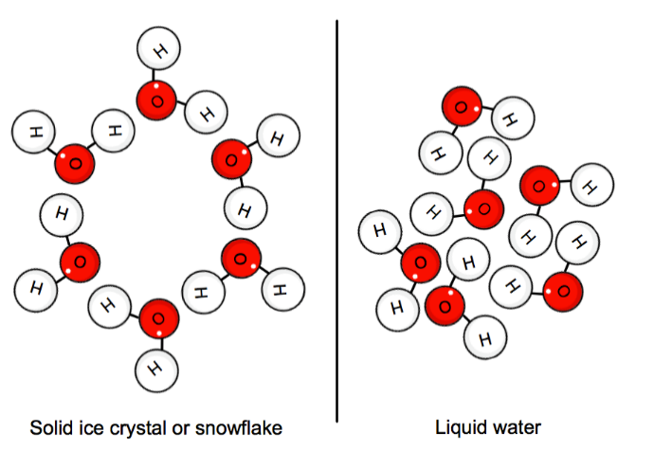

Note that the diagrams (or structural formulae) indicate that hydrogen are

*still bonded* to oxygen in the same way … No bond breaking has occurred and

**no new bonds were made…when comparing reactants to products… only the**

**arrangement in space of the individual molecules has changed…**

This means there is NO REARRANGEMENT of atoms are symbolized

when comparing the reactant(s) to the product(s). On the reactant side

hydrogen is bonded to oxygen and that is true on the product side as well.

This is a fine line of distinction … but it is an important and valuable one.

**Bond breaking doesn’t occur when we boil water!**

**Think about it**. What is produced when we break the bonds of water (H2O)?

c) What about the term: DISSOLVING?

When sodium chloride solid (NaCl(s)) is added to water, the solid *dissolves*.

The bond holding the Na+1 to the Cl-1 ion is disrupted by an attraction to the

surrounding water and the ions tend to separate from each other. The ions are attracted to the water molecules and are hydrated by the molecules, but this attraction is NOT the same thing as a new bond. There is no significant new

sharing or loss/gain of electrons.

Boil away the water, and the NaCl(s) is reconstituted. This dissolving process of a

solid in water is a reversible & physical change … not technically a chemical

reaction.

This dissolving process in water produces an aqueous solution (a substance

dissolved in water)

Thus: NaCl(aq) This symbol indicates that the chemical substance,

(NaCl) has been added to and dissolved in water.

This is the compound Thus, both NaCl and H2O are present. This symbol

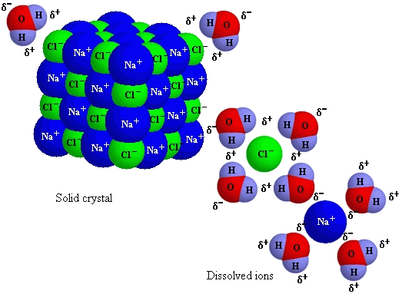 indicates the production of a mixture of materials, NOT

a new compound.

The sodium ion and chloride ion, however, are no

longer bonded to each other, regardless of what the

symbolism suggests. The bond between sodium ion

and chloride ion has been broken … and the ions are

now surrounded by (hydrated by) water molecules.

We will get to the specifics of this process later in the

term … But, right now it is important to note how

the symbolism of NaCl(aq) can be visualized.

Note that this symbolizes a *mixture* of

ions and water … NOT a new

compound. Technically NO NEW

BONDS are produced.

<https://socratic.org/questions/547faba7581e2a77ba3a945a>

a) There are few common means of writing the dissolution of a compound in water in

water. Note that there is NO REARRANGEMENT when comparing the

reactant side to the product side.

H2O

a) NaCl(s) → NaCl(aq) The (aq) indicates the formation of the mixture.

OR:

b) NaCl(s) + H2O(ℓ) → NaCl(aq)

OR:

Note this is a nice means of indicating dissolving … though it is not always used. It has advantages in that is shows the breaking of bonds, but no new bond is made

H2O

c) NaCl(s) → Na+1(aq) + Cl-1(aq)

3) **phase changes** such as the melting of ice to water are also physical changes.

a) NO NEW BONDS are produced when solid water-ice melts to liquid water.

b) It is common to write the melting of water-ice to liquid water as:

Energy + H2O(s) → H2O(ℓ)

OR … simply:

H2O(s) → H2O(ℓ)

**TRY THIS! Vocabulary**… When reading, you can tell the difference, by some of the technical terms

CHEMICAL REACTIONS versus Physical Changes / Properties

(involve breaking AND making new bonds (May involve breaking bonds, but **no new bonds are made**

&/or involving changes in the e- clouds) Physical changes may occur with chemical reactions)

reduce / reduction dissolve / stir (so as to make an aqueous solution)

oxidize / oxidation **mix** / mixture combust / burn / flammable melt / fuse

rust / corrode vaporize / boil / evaporate

react / **bond** sublime or sublimate

ionize / ionized distill

neutralize freeze

decompose condense

cook / grill filter / separate

synthesize density (when calculating, comparing samples)

precipitate measuring / comparing masses

flash point measuring / comparing volumes

polymerize color

change in oxidation state liquefied, solidified, (change in phase)

smell

For questions 1 -11 use the clues given in each problem. Identify the situation as a chemical reaction (or (a chemical property) or a physical change / property. Some terms are highlighted just to help.

1) ____________________ Pat **dissolved** 10.0 grams of NaOH(s) in water into the ions Na+1 and (OH)-1

2) ____________________ Jordan grilled up a couple of steaks for the late guests, getting a nice char on them.

3) ____________________ Terry **melted** the butter in the hot pan.

4) ____________________ Taylor saw that the metal door handle had rusted from its shiny iron (Fe(s)) to

a reddish iron oxide (Fe2O3(s)) and replaced it.

5 ) ___________________ Alex was careful to **distill** the solution to isolate a sample of pure water.

6) ___________________ Perry used baking soda to **neutralize** the tomato sauce making the taste less tangy.

Bubbles of CO2(g) were produced.

7) ___________________ Sam shredded each document listing a social security number into fine bits.

8) ___________________ Ryan burned the marshmallows in the campfire, turning them black.

9) ____________________Sidney determined the melting point of the solid to be 58.3°C

10) ___________________Shaun noted that a can of Coke was **denser** than Diet Coke, in water

11) ___________________Aidan **filtered** the coffee, using unbleached, paper filters.

Answers:

1) physical change 2) chemical reaction 3) physical change 4) chemical reaction 5) physical change 6) chemical reaction

7) physical change 8) chemical change 9) physical change 10) physical change 11) physical change

G) **Focus on identifying the energy exchange**: Exothermic vs. Endothermic

We will discuss the ideas of potential energy later …for now let’s work on identification and meaning.

Consider: **164 kJ + 2 NH4Cl(s) + Ba(OH)2(s) 🡪 2 NH3(g) + 2 H2O(ℓ) + BaCl2(s)**

reactants products

Reactants = “*ingredients ”

Products = well, um…products!

**kJ = energy (kJ is a new unit)**

When the units of kJ are on the reactant side, there is a net absorption of energy from the environment

relative to the amount of energy released. This is called an endothermic reaction.

When the unit kJ is on the product side, there is a net release of energy from the formation of products

into the environment. This is called an exothermic exchange in terms of energy.

1) We can classify BOTH chemical reactions & physical changes with the shared vocabulary

terms of: *exothermic and endothermic.

2) Not all chemical changes are exothermic and not all are endothermic …the same goes for

physical changes. One may be exothermic while another may be endothermic.

3) We classify a chemical reaction (overall) as *either exothermic or endothermic

based upon the amount of energy required to **break bonds of reactants**, relative to the

amount of energy **released as new bonds are made** …

a) When we write a chemical reaction, we tend to write, only the difference between

these two processes of breaking bonds and making new bonds.

Imagine… A-B and Y-Z react to form A-Z and Y-B.

Imagine it takes 500 kJ of energy to break up A-B and Y-Z bonds

Imagine 700 kJ of energy are released as the products A-Z and Y-B are made.

500 kJ + AB + YZ → AZ + YB + 700 kJ

We would tend to write: **AB + YZ → AZ + YB + 200 kJ**

This tells us, that 200 kJ of energy were released into the surrounding

environment, (air or water) as the new bonds were made.

4) Exothermic changes: Chemical reactions or physical changes in which *more energy is

released (lost) as new bonds or attractions are made, then is gained as old bonds or attractions

are broken.

a) The released energy demonstrates a lessening of enthalpy. Heat content of the

products is less than the heat content of the reactants.

i) From the point of view of the chemicals, the surrounding environment,

the air or the water, will become *warmer, because energy is being lost by the chemicals to

the surroundings, as the new bonds are formed.

b) Chemical reactions as well as physical changes (e.g. freezing water to ice or

dissolving NaOH(s) in water), can be exothermic, for slightly different reasons.

Each however, result in more energy being released than absorbed.

This energy is lost to the environment (the surrounding air or water). The temperature of the surroundings goes up!

e.g.) 2 Al(s) + 6 HCl(aq) → 2 AlCl3(aq) + 3 H2(g) + 1,055 kJ

4 Fe(s) + 3 O2(g) → 2 Fe2O3(s) + 1,648 kJ

CH4(g) + O2(g) → CO2(g) + 2 H2O(ℓ) + 890 kJ (The flame!!!)

TAKE HOME MESSAGE: Were exothermic changes to occur in water or air we should expect to

see an increase in the temperature of the water or air, as the reactions proceed. Think about how

a room warms as an exothermic fire burns in the fireplace. But also, think about how ice freezing,

is exothermic. Energy must be extracted or lost from the liquid water to turn to ice. Thus, a freezer

must be in constant operation to keep removing the lost heat from all the food stored in it.

5) The opposite of an exothermic exchange is an *endothermic exchange

Examples of endothermic changes: Physical changes or chemical reactions in which more

energy is absorbed by the reactants, as bonds are broken, then is released as new bonds are

made. The resulting **products tend to have more chemical energy that the reactants (we**

**are “storing energy).** **The temperature of the surrounding air or water in which the**

**chemicals react, decreases.**

Photosynthesis: 2803 kJ + 6 CO2(g) + 6 H2O(ℓ) → C6H12O6(aq) + 6 O2(g)

Physical Change: Dissolving of NH4NO3 in water

This energy is absorbed from the water surrounding the NH4NO3. The energy is used to drive the dissolving process; thus the temperature of the water goes down.

24 kJ + NH4NO3 + H2O(ℓ) → NH4+1(aq) + NO3-1(aq)

H) Some Everyday Applications of thinking in terms of: Exothermic and Endothermic

Combustion: Fire: CxHy + O2(g) 🡪 CO2(g) + H2O(g) + kJ

Water freezing to ice

Condensing water vapor to liquid water (The sweating glass)

Perspiration: A study in some counterintuitive thinking:

Note: This is why you feel chilly getting out of a hot shower. The reasoning is the same.

So, let’s engage in some everyday refined thinking!

Have you ever heard that perspiring is a cooling activity? It seems weird to think about this for

many of us.

Well here is the key: Consider your body temperature at *97.4F or so to the environmental temperature

Now consider working out, or playing your sport, or hiking. Imagine the temperature is 85F.

As you work, bonds are being broken and made … You are using energy and you are using your

muscle.

<https://hmns.uq.edu.au/article/2020/02/why-do-i-sweat-so-much>

**TRY THIS! Frayer Diagrams for Exothermic / Endothermic**

EXOTHERMIC

Essential Nonessential

Exemplar Non-exemplar

ENDOTHERMIC

Essential Nonessential

Exemplar Non-exemplar

**TRY THIS!**

___1.  *I am providing you with "before and after" diagrams for this question. Analyze them to see if they help you.*

A student took the temperature of 150.0 mL of water. She then dissolved 5.00 grams of NH4Cl(s) into

the water according to the equation

H2O(l)

NH4Cl(s) + 14.7 kJ 🡪 NH4+1(aq) + Cl-1(aq)

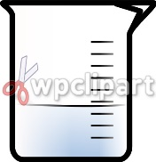



just 150 mL water 150 mL of water plus

the dissolving NH4Cl

<http://www.wpclipart.com/science/beaker/beaker.jpg>

**THINK! Is this dissolving process, endothermic or exothermic?**

**Is the chemical NH4Cl absorbing energy from the water, OR releasing energy into the water?**

**If the chemical were absorbing energy, what should happen to the temperature of the water?**

**If the chemical were releasing energy, what should happen to the temperature of the water?**

She took the temperature of the resulting solution. Using the above equation and her knowledge of

thermal energy, she could predict that the reaction was:

a) endothermic & the temperature of the water increased

b) endothermic & the temperature of the water decreased

c) exothermic & the temperature of the water increased

d) exothermic & the temperature of the water decreased

___2 Given the reaction : A(s) +B(aq) 🡪 C(s) + D(aq) + 170 kJ

If the reaction occurred in water, the temperature of the system at the end of the reaction should have:

a) increased b) decreased c) remained the same

**Think: Is this chemical reaction endothermic or exothermic?**

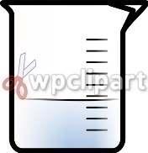

**Are the chemicals, as they react, absorbing energy from the environment or are**

**the chemicals, as they react, releasing energy into the environment?**

**If the chemicals were absorbing energy, what should happen to the temperature of the water?**

**If the chemicals were releasing energy, what should happen to the temperature of the water?**

For questions 3 - 5 use the following choices. A choice may be used once, more than once or not at all.

a) endothermic b) *exothermic*

___3) 52.4 kJ + 2 C(g) + 2 H2(g) 🡪 C2H4(g)

H2O(ℓ) Water, over an arrow, suggests something is being dissolved

___4) NaOH(s) 🡪 Na+1(aq) + OH-1(aq) + 44.3 kJ in water, thus, this is just a physical change…

___5) HCl(aq) + Fe(s) 🡪 FeCl2(aq) + H2(g) + 598 kJ

****************

___6) A student took the temperature of 150.0 mL of water. She then dissolved 30.00 grams of KClO3(s) into

the water according to the equation:

H2O(ℓ)

KClO3(s) + 41 kJ 🡪 K+1(aq) + ClO3-1(aq)

She took the temperature of the resulting aqueous solution. Using the above information and her

knowledge of chemistry she could infer that the reaction was :

a) endothermic & the temperature of the surrounding water increased

b) exothermic & the temperature of the surround water increased

c) exothermic & the temperature of the surrounding water decreased

d) endothermic & the temperature of the surrounding water decreased

7) Imagine that you and a friend are sitting in front of a wood fire. The reacting chemicals in this case, are the

wood and dioxygen (O2(g)) gas from the air. Is the reaction exothermic or endothermic?

Wood + O2(g) → CO2(g) + H2O(g)

8) Consider liquid water freezing into solid water-ice. Is this exothermic or endothermic?

H2O(l) → H2O(s)

9) What confuses you or what do you think you now know?

Ans:

1) b energy is absorbed by the reactants. the source of energy is most probably from the water, thus energy would move from the water to the chemicals, and the temperature of the resulting solution would be lower than the water's temperature.

2) a it is an exothermic reaction (energy is on the product side) ... the chemicals release more energy than absorbed and thus the water gains that energy.

3) a 4) b 5) b 6) d

7) exothermic ... energy is being released from the reacting chemicals ... far more than was added to get the fire going...

8) exothermic ... this is a cooling process and yes, also exothermic ... the chemical (water) must lose energy to the environment...

**Try This: Identify chemical reactions vs. physical changes.**

Answer each of the following questions **by selecting or by providing the most correct answer**. Remember to be critical readers and thinkers, remember to analyze, circle important terms, and redefine terms.

Really look for new bonds being made. Or, you may look for 2 to 3 of the 5 visual signs of a chemical reaction. Bold color change; new solid produced; new gas produced; new liquid produced; energy exchange. **Go to my website** [**www.scientiaestubique.com**](http://www.scientiaestubique.com) **, open the Unit 1 Part 2 note packet for the answers.**

1) Given: 2 N2(g) + 3 O2(g) → 2 N2O3(g) + 200 kJ

A student claimed that the above represents a chemical reaction, primarily. She mixed two colorless

gases and added energy to a flask. She noticed a blue liquid with an awful odor evolved. The flask

became very warm.

Is the student correct? *Yes Defend your answer: * New bonds are made. N is bonded to O on the

product side, when compared to the reactant side. Or, we could note that there is a bold color change,

new gas, and energy released (3 of the 5 visuals)

2) Given: 2 NaOH(aq) + CuSO4(aq) → Cu(OH)2 (s) + 2 Na2SO4)(aq)  + 90 kJ

A student claimed that the above represents a chemical reaction, primarily. He combined a clear

solution with a slightly blue solution making a third blue solution. Then he noticed that a blue colored

solid formed at the bottom of the test tube and the rest of the solution went clear. He didn’t notice a big

change in temperature, just a slight warming effect.

Is the student correct? *Yes Defend your answer: *New bonds are made. Note that the Cu is

Bonded to the (OH) species on the product side. This is new and different with respect to the reactant

side. Or, you could cite that there is a bold color change, new solid, and there was an energy exchange

in terms of the exothermic nature of the reaction.

3) Given: 10 kJ + C6H4Cl2(s) → C6H4Cl2(ℓ)

A student claimed that the above represents a chemical reaction, primarily. He had to warm a flask

containing the solid and noticed that it seemed to melt into a liquid.

Is the student correct? *No Defend your answer: *There are no new bonds produced. C is still

bonded to the same H and Cl atoms. Or, from a visual point of view, the liquid is not “new” it is just the

melted form of the original compound. For example frozen water (H2O(s)) is really the same chemical

as liquid water (H2O(ℓ)). This is just a physical change. There is an energy exchange. The change is

endothermic overall – but there are not enough other visual clues to classify this as a chemical *reaction*

4) A student took the temperature of 150.0 mL of water. She then dissolved 30.00 grams of NaOH(s) into

the water according to the equation:

H2O (𝓁)

NaOH (s) → Na+1(aq) + (OH)-1(aq) + 44.5 kJ

She noticed that the solid dissolved into the water, but not much else happened, except that the beaker

became hot to the touch.

1) endothermic & a chemical reaction

2) exothermic & a chemical reaction

3) exothermic & a physical change

4) endothermic & a physical change

answer = *3

5) A student dropped some calcium metal into a beaker with about 100 mL of water. The student noticed a

bubbling almost like a boiling, and a white solid formed. The beaker became very hot to hold.

This most probably is classified as

1) endothermic & a chemical reaction

2) exothermic & a chemical reaction

3) exothermic & a physical change

4) endothermic & a physical change answer = *2

6) A student was writing her final paper. She was doing some research and came across the following passage.

One theory as to why old paintings discolor surrounds the use of lead-based pigments. The

Romans and Greeks often used carbonate white lead, which is a mixture of PbCO3 and Pb(OH)2.

Later, other white pigments such as PbSO4 and PbO were often used. Chrome yellow/orange

pigments contained quantities of PbCrO4. Red lead, Pb3O4 was used extensively as a primer paint.

A commonly held belief is that the lead-containing pigments react with hydrogen sulfide gas

(H2S) in polluted air to form the black precipitate lead sulfide (PbS). On exposure all of the

pigments darken due to the formation of the black lead sulfide (PbS). (Karvkstis & Hecke Chemistry Connections 2003 p. 57)

In her paper, she included a sample equation:

PbCO3(s) (white solid) + H2S(g) → PbS(s) (black solid) +H2O(g) + CO2(g)

Should she classify the fading of old paintings, as described above as a chemical reaction or as a

physical change, in her paper? Why?

*It is a chemical change. First the reading uses the term, react, and that implies chemistry. Secondly,

a new solid, and two new gases are produced in the example equation. When such new materials

are produced, it is an indication of a chemical reaction,

**Try This!**

DIRECTIONS: Work with your notes, the internet, a neighbor. Recall that the unit kJ refers to energy. Identify which of the following should be classified as

a) a chemical reaction because there are new bonds made

b) a physical change because there are NO NEW bonds made

___1) 2 Mg(s) + TiCl4(ℓ) → Ti(s) + 2 MgCl2(s) + kJ

___2) PF3(g) + 3 H2O(ℓ) → H3PO3(aq) + 3 HF(aq) + kJ

___3) Al2(CO3)3(s) + 3 Ca(OH)2(aq) → 2 Al(OH)3(aq) + 3CaCO3(s) + kJ

___4) kJ + CaO(s) + SiO2(ℓ) → CaSiO3(l)

___5) kJ + KCl(s) + H2O(ℓ) → K+1(aq) + Cl-1(aq)

___6) kJ + C12H22O11(s) → C12H22O11(ℓ)

___7) kJ + 4 Cr(s) + 4 K(s) + 7 O2(g) → 2 K2Cr2O7(s)

___8) H2O(g) → H2O(ℓ) + kJ

___9) 2 CH3OH(g) + 3 O2(g) → 2 CO2(g) + 4 H2O(g)+ kJ

___10) 4 KO2(s) + 2 H2O(g) + 4 CO2(g) → 4 KHCO3(s) + 3 O2(g) + kJ

11) Using the number of each reaction above (#1 – 10) identify the 6 exothermic exchanges (*regardless as to*

*whether they represent a chemical reaction or physical change*)

The six exothermic exchanges are: __________________________________________________

BTW: #10 is how oxygen is generated in emergency oxygen masks on planes … You know, those bags that drop down?

VII) Dimensions of Matter

A) Mass: the dimension of matter which is a measure of the quantity of matter an object possesses OR

*the property of an object that causes it to have weight in a gravitational field

1) Mass is best described using physics & that really doesn’t help first-year chemistry students,

yet the concept of INERTIA is an elegant description. Inertia is the tendency for an object to

to resist changes in its motion.

The odds of an object to resist changes in its state of motion vary with its mass. The

greater an object’s inertia, the greater the object’s mass. A more massive object will

have a greater tendency to resist changes in its motion. A less massive object, will have

a relatively lesser tendency to resist changes in its motion (It will be altered or moved,

more easily. Thus, it has less mass.)

...Think of a quarter and a glass

2) basic International System (SI) unit = kilograms

Note: 1 kilogram = 1,000 grams note: the prefix kilo translates as “one thousand”

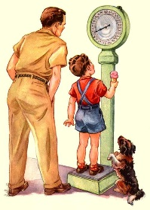 e.g) 1 kg = 1,000 grams or 0.500 kg = 500. g

3) Weight: a dimension of matter which describes the *effect of gravity on a mass or that which

a mass has in a gravitational field. (Weight may change as the strength of the

gravitational field changes, mass tends to be conserved and does not change.)

a) SI unit: kg·m/s2 or Newton

English unit: pound (lb)

When we measure an object on a balance, we are measuring against a standard mass. And

while it isn’t surprising that mass and weight are used interchangeably –it is *incorrect* to

do so, really. You see, the concept of “weight” becomes important, **only when the force**

**exerted by gravity is changed.** Since that force is a constant from the balance to your desk

(unless your desk is at the top of Mt. Everest), the term weight is not wholly appropriate.

However, when the gravitational force changes, the **weight** of an object from one point to

another, can change, but its mass (the inertia) is essentially constant.

b) Think of an astronaut weighing 120 lbs. here on Earth. We all know that when she gets to the

Moon, she will experience a sense of “weightlessness”, *to some degree*. She can ...jump

higher, hit a golf ball farther.... So, what has happened? Did she lose mass? If so, which part

of her body did she have to cut off? WHAT!? Is there any another explanation?



Check out: <http://www.exploratorium.edu/ronh/weight/>

B) Volume: the dimension of matter which deals with *the (amount of) space occupied by matter

1) regular cube: Length x Width x Height * e.g. 1 cm x 1 cm x 1 cm = 1 cm3 or 1 cc

a) units: Liter (L), milliliter (mL), or cubic centimeter (cm3)

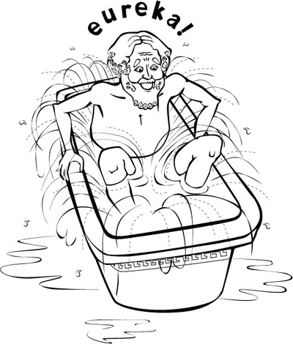

2) Archimedes and Water displacement

3) 1 Liter = 1,000 mL = 1,000 cm3 (cubic centimeter or *cc*)

http://www.squidoo.com/King_Bidgood

<http://core.ecu.edu/chem/chemlab/equipment/evolumetricflask.htm> cubic decimeter

<http://www.chem.uiuc.edu/webFunChem/volume/volume3.htm> <http://core.ecu.edu/chem/chemlab/equipment/egcylinder.htm>

4) solids and liquids tend to have * constant volumes

a) If you transfer a solid object from one vessel to a different yet larger vessel,

the volume of the solid *would remain the same (would be unchanged)

b) When you transfer 100 mL of water from a 400 mL beaker to a 1,000 mL beaker,

the volume of the water (liquid) * remains the same

5) gases have no constant volume. The volume of a gas may be reduced or expanded

dramatically, as the conditions of temperature and pressure change.

think: s.c.u.b.a., hot air ballooning, human breathing, ear's popping, home heating

systems, aerosol spray cans, butane lighters , phlebotomy etc...

C) Density = Mass or Density = Mass/Volume

Volume

Maybe the following is a different way of seeing density...

1)Density is a measure of * the *compactness* with which mass is packed.

Note: * density ≠ heaviness

Something may be heavier than another item – but not denser. Heaviness is

more closely related to mass.

When comparing two items of similar VOLUME, and one is heavier than the

other, you may assume the heavier one is denser.

**Let’s think: Consider 1 ton of duck feathers and 1 ton of bricks.**

<https://courses.lumenlearning.com/suny-physics/chapter/11-2-density/>

Which weighs more: 1 ton of feathers or 1 ton of bricks?

Which has the greater mass? 1 ton of feathers or 1 ton of bricks?

Which would you rather fall onto from a height of 15 feet?

In which is the matter more compact/ has the greater density?

(Notice then, by your own analysis, greater density has very little to do with “heavier”.)

a) essentially, ***at a constant temperature and pressure***, the density of a substance is a

**constant**. Density is a constant (an intensive property) for a substance at a specific

temperature and pressure, but change those conditions of temperature and pressure,

and the density can change.

i) Nonetheless, density is really helpful when trying to identify a substance.

ii) as you increase the mass of a substance, the sample become more voluminous

(Volume, scales with the mass). We will see this in our Measurement Lab

b) Compression (especially of a gas sample) increases density *(it gets more compacted)

c) Heating matter, tends to result in the decrease of a material's density

....gases when heated, tend to increase volume (expand).... thus decrease density

....solid metals when heated, tend to increase in volume and thus expand ...

(Some mixtures of metals [alloys] do not undergo such a change)

i) in the above cases of heating, the substance becomes *less compacted

**TRY THIS: ∞**Consider two cubes of pure iron

Barbara has 20 cm3 of iron and Meghan has 60 cm3 of iron, *at the same temperature and*

*pressure*. Which statement is FALSE?

___ Meghan’s sample has 3 times the density of Barb's sample.

___ Meghan's sample has 3 times the volume of Barb’s sample.

___ Meghan's sample has 3 times the mass of Barb's sample.

Defend your reasoning: *The temperature and pressure of the iron samples are the same, thus

the density is the same. Density is a constant. Volume of a sample scales with the mass, thus

M/V is the same.

**TRY THIS: ∞** Which member of the following pairs has the greater density? (Circle one member of each pair

as the answer) One pair is a trick ... in one of the pairs both examples have the same density ... can you

figure it out and why?

pair 1) liquid water (H2O(l)) *or* ice (H2O(s))

pair 2) helium (He(g)) at 0°C and 1 atm *or* air at 0°C and 1 atm

pair 3) olive oil *or* water

pair 4) 25 L of CO2(g) at 0°C and 1 atm *or* 1 L of CO2(g) at 0°C and 1 atm

Identify the “trick pair and defend your thinking as to why it is a "trick pair": Be sure to have a “because”

statement that cites data, a specific theory from your notes, cites an equation or uses an appropriate metaphor.

* The 4th pair is the trick pair. The densities are the same. The members of the pair are the

same chemical and each is at the same temperature and pressure. They have the same

density *because* density of a chemical is a constant (the same), regardless of volume or

mass, when the conditions of temperature and pressure are the same.

D) Pressure: Pressure is the force exerted on an object, when matter (as in atoms or molecules) come in

contact with that object.

Pressure = (mass)(acceleration) or Pressure = Force

Area Area

Conclusion: (With a plea of indulgence to my physicist friends)… Essentially pressure exerted

by a chemical is affected by

* *The number of particles
* *How fast a molecule moves &/or collides with the sides of a container

(This is related to the temperature of the matter, as temperature affects the

acceleration part of the equation)

* *The mass of each particle which collides.
* As with energy, gases will move from areas of high pressure to low pressure.

Consider a single molecule of the gas, helium trapped in a sealed cylinder.

This is where pressure is measured…as the molecule hits the interior of the cylinder. Now, imagine different scenarios, in which the molecule moves faster and hits the interior. Pressure (the force exerted) would increase.

The molecule in the The molecule as it accelerates

middle of the container and impacts the interior of the

cylinder. We can measure this impact.

**Each impact produces “pressure”**



1) Consider a bottle of carbonated water… heat it up; let it “de-fizz” …

2) To consider the effects of area on exerted pressure, think of a high heel shoe

Check Out: Texas A & M(ruler): <https://www.youtube.com/watch?v=0pJlTzz5pDw&t=13s>

Now consider a cylinder with a moveable piston with thousands of trapped molecules of helium

Pushing down the plunger increases pressure

Imagine pushing down on the sealed sample of helium gas. Have the number of molecules changed? Did you add more matter? … No, the molecules simply have less empty space between them. They have been pressurized (compressed).

versus

Do you understand that when compressed as in the second diagram, the molecules will slam into

the sides of the cylinder more frequently? Thus, what happens to the pressure of gas in the

second cylinder?

What if you were to heat the gas in the cylinder? What will happen to the acceleration of the

molecules? And what will happen to the pressure?

Pressure = **(mass)(acceleration)**

**Area**

Think About This: **We live at the bottom of an ocean of air...**

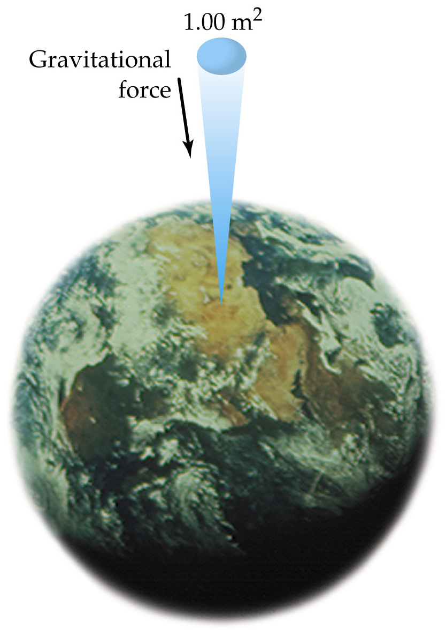

[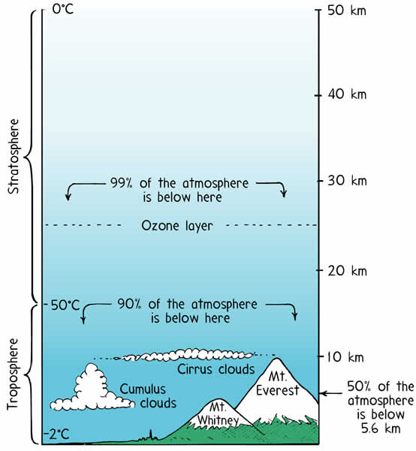](http://www.ucar.edu/learn/1_1_1.htm)

<http://wps.prenhall.com/wps/media/objects/602/616516/Chapter_09.html>

A column of air 1.00 m2 in cross-sectional

area extending from the earth’s surface through

the upper atmosphere has a mass of about

10,300kg, producing an *atmospheric* pressure

of approximately 101.3 kPa (also called,

1 atmosphere or 1 atm)

http://tonydude.net/NaturalScience100/Topics/2Earth/3atmosphere.html

Now... How does pressure change when we leave our ocean of air, and

dive into our ocean of water??

Surface Air Pressure = 1 atmosphere (1 atm) or 101.3 kPa





10 meters underwater = 2 atmospheres

(or 202.6 kPa)

**Think about the math …. Assuming:**

**Pressure = Force = mass (acceleration)**

**Area Area**

**As we go deeper below the surface of the**

**ocean, there is an increasing mass of**

**water above our “area”. Couple this**

**increasing mass of water, to the mass of the**

**gaseous atmosphere it is not too surprising**

**to conclude that the pressure is increasing!**

Personal note: I am still in wonderment, that any

cellular creatures can live **and thrive** **2,100 meters** (and more) below the surface of the ocean

at the level of the hydrothermal vents! e.g. frilled

shark, giant tube worms, vampire squid, pacific

viperfish.... How does that work??? Really … I don’t get it… I have questions!



20 meters = 3 atm (or 303.9 kPa)

underwater



30 meters = 4 atm (or 404.12 kPa)

MCj02001950000[1]

**How We Breath! It’s About Pressure!**



**Expiration**:

Pulmonary (Lung) volume decreases as the diaphragm returns to a (more) neutral position & the rib cage drops down. This decrease in volume, increases the intrapulmonary pressure and air is pushed out of the lungs into the atmosphere.

**Inspiration**: Pulmonary volume increases as the diaphragm drops & the rib cage rises. This increases lung volume & decreases intrapulmonary pressure and air is pushed into the lungs from the area of greater pressure, outside the body

1 atm

1 atm

1 atm

**1.004 atm**

1 atm

**0.9973atm**

1 atm

1 atm

Rayner-Canham: Descriptive Inorganic Chemistry

Notice that the atmospheric pressure (the pressure outside of the body) is 1 atm. It does not change in

this example. Only the intrapulmonary pressure changes. Air is exchanged as it moves from an area of

relatively higher pressure to an area relatively lower pressure. The part of the brain which controls

much of the action of the diaphragm is the medulla oblongata.

Can you imagine the impacts on one’s breathing as s/he climbs up a high mountain?

**Popping Ears: Pressure, Again!**

**Key Idea:** **You want the air in your ear canal and the air in the middle ear to have the same pressure.**

If they do, then the eardrum has equal pressure on both sides and it is smooth and happy.

On the other side of the ear drum is a hollow space filled with air, called the **middle ear**.

In order for the middle ear to equalize its pressure, there is a thin tube called the **Eustachian tube** that connects the middle ear's air chamber to the throat. Air can flow back and forth through the tube, and this keeps the air pressure in the middle air equal with the outside air pressure.

If your Eustachian tube is clogged or narrowed for any reason, then your middle ear gets shut off and becomes a **closed chamber**. It holds air at 14.7 PSI (equal to 1 atmosphere of pressure). When you swim to the bottom of the deep end, the water is pressing into the ear canal at 19 PSI (equal to 1.29 atm), so the ear drum bows inward toward the person’s body, because of the pressure difference. Since the ear drum is full of nerves, you feel this bowing as pain.

To solve the problem, you can **equalize the pressure**. When you start to feel pain in your ears, hold your nose shut with your fingers and blow into your nose. You will hear your ears pop and the pain should go away. By blowing, you increase the air pressure in your lungs and throat, and it blows the air up your Eustachian tube into the middle ear to equalize the pressure. When you rise back up to the surface, the middle ear will contain excess pressure, but the Eustachian tube generally releases it automatically. If not, try yawning to open up the Eustachian tubes. http://science.howstuffworks.com/question193.htm

E) Extensive vs. Intensive Properties: As well as being described as anything with mass and volume,

Matter has * extensive and intensive physical properties

|  |  |
| --- | --- |
| **An Extensive Property is**  dependent upon "**how** **much**" of the substance there is Or, it is one that changes as the size of the sample changes | **An Intensive Property is**  specific to the substance and is INDEPENDENT of the system's size. An intensive property scales with changes in,or to the size of the system . |
| Mass | Density |
| Volume | Pressure |
| Length | temperature (for a system in thermal equilibrium) |
| enthalpy (energy) | Malleability (metal pounded to a sheet) |
| number of molecules | Melting point |
| Weight | Odor |

**Proof 1:**  Think of ice, but picture a massive, or a titanic (?) iceberg, if you will, and then picture an ice cube from your

freezer. Assume they are both pure water (ice) at -10ºC.

Both temperatures are identical ... hence temperature is intensive (it does not depend upon the size of the system)

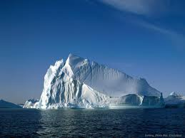Now think about melting the two samples with a meeker burner. Can you suggest the temperature at which each sample of ice will melt? Both will melt at 0 ºC. They are both water, so the melting point is intensive. Now, think about the amount of energy required to melt each sample. Is the amount the same? No. Due to the greater mass of the iceberg, we can imagine it will take a phenomenally larger amount of energy to melt the iceberg to liquid water. Hence energy is extensive (dependent on the size). Note that this energy is calculated by ΔH = mass(H fusion): a mass-dependent equation.

iceberg vs.

ice cube

<http://www.hdwallpapersdepot.com/iceberg-wallpapers.html>

**Proof 2:** Here’s another way to think of this: When you add two variables together and the result doubles then the

property that changed is extensive. Any property that remains the same, is an intensive property.

Imagine a cylinder with a moveable piston with 1 Liter of a gas at STP. Now, to it, add to it a second 1-liter sample of the same gas at STP.

Think: The volume doubles, the mass doubles. (Thus, each is extensive).

But the new system will still be at standard temperature (0ºC) and standard pressure at

(1 atm), making temperature and pressure (in this case) intensive. The density of the gas is the same (volume scaled with mass), thus density is an intensive property.

**1) Application of an intensive property: Specific Heat**

a) substances differ in their specific heat values. We can use specific heat to help identify

substances. Also, the values of specific heat change as the phase of a substance changes.

e.g.) H2O(l) = 4.18 J/ g·°C & H2O(s) = 2.03 J/ g ·°C

b) specific heat (c) = the # of joules required to change the temperature of **1.00 g** of substance

**by 1.0 ºC**). It is an intensive property.

i) Study the unit: J/ g ·°C this means the value is a certain number of Joules of

energy per 1 gram and 1°C. You see that “per 1 gram” implies we are dealing with

a constant – or an intensive property. The value will not change – regardless of the

mass of substance because it is referenced to only 1 gram.

Thus, an intensive property, like specific heat is analogous to the unit price

of a tee shirt at Old Navy. Let’s say the price of a tee is $5.00 per shirt.

It does not matter how many tee shirts you buy; the price is a constant. The total

bill may change based upon the number purchased, but not the price per tee.

ii) There is a general rule about specific heat and changes in temperature, the greater the

specific heat value, the slower temperature change occurs.

★★**Hence:  *Slow to heat up, Slow to cool down.***



iii) Check out: <https://2012books.lardbucket.org/books/principles-of-general-chemistry-v1.0/s09-03-calorimetry.html> for more on specific heat and calorimetry

The high specific heat of liquid water has important implications for life on Earth. A given mass of water releases more than five times as much heat for a 1°C temperature change as does the same mass of limestone or granite. Consequently, coastal regions of our planet tend to have less variable climates than regions in the center of a continent. After absorbing large amounts of thermal energy from the sun in summer, the water slowly releases the energy during the winter, thus keeping coastal areas warmer than otherwise would be expected (see the diagram on the next page). Water’s capacity to absorb large amounts of energy without undergoing a large increase in temperature also explains why swimming pools and waterbeds are usually heated. Heat must be applied to raise the temperature of the water to a comfortable level for swimming or sleeping and to maintain that level as heat is exchanged with the surroundings. Moreover, because the human body is about 70% water by mass, a great deal of energy is required to change its temperature by even 1°C. Consequently, the mechanism for maintaining our body temperature at about 37°C does not have to be as finely tuned as would be necessary if our bodies were primarily composed of a substance with a lower specific heat.

**Consider This: Boiling Water in a Paper Cup!!**

Title: The High Specific Heat of Liquid Water Has Major Effects on Climate

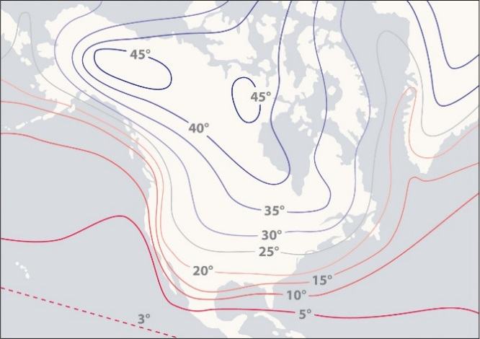

Regions that are near very large bodies of water, such as oceans or lakes, tend to have smaller temperature differences between summer and winter months than regions in the center of a continent. The contours on this map show the difference between January and July monthly mean surface temperatures (in degrees Celsius).

|  |  |
| --- | --- |
| **Selected Examples of Specific Heat Values** | |
| Substance or *Mixture* | Specific Heat  (J/g∙°C) |
| **Water (liquid)** | **4.18** |
| Water (gaseous) | 2.06 |
| Aluminum | 0.895 |
| Ethanol | 2.4 |
| Iron | 0.46 |
| Lead | 0.130 |
| Mercury | 0.14 |
| Gold | 0.129 |
| Diamond (C(s)) | 0.509 |
| Graphite (C(s)) | 0.709 |
| Silicon Dioxide (quartz) | 0.742 |
| Calcium Carbonate | 0.915 |

Check out the specific heat values for liquid water & water vapor (gaseous water). Which one will cool faster?

Which one can get up to a dangerously high temperature? Does this make sense in terms of your life experiences?

Why is the water in a pot of boiling water slow to cool down, but the actual pot, cools faster?

Why might diamonds be used in computers as heat sinks?

**QUESTIONS: For questions 1-5 use the table of specific heat values.**

1) Which sample would increase in temperature faster? Explain your answer. *(Be sure to have a* *“because*

*statement” in your answer. This “because statement” should include a quote from notes, a reading, a metaphor or an equation.)*

**20 grams of ethanol (alcohol) or 20 grams of water?**

2) Which would make a more sensitive fluid for a thermometer: Mercury or Ethanol?

3) A saucepan is very often made of stainless steel, which is an alloy made primarily of iron. When you

put a pan full of water on the stove which heats up faster, the pan or the water in the pan?

_______________ Defend your answer *(Be sure to have a “because statement” in your answer.*

Why?

Answers: 1) 20 grams of ethanol will heat up faster *because* ethanol has a lower specific heat of 2.4 J/g K, compared to water’s 4.18 J/g K. This means that every

gram of ethanol requires only 2.4 J of absorbed energy to increase its temperature. Since it requires a lesser amount of energy, it will heat up faster.

2) Mercury.

3) The pan. The pan is mostly iron, so the specific heat is roughly close to 0.46 J/g K. The specific heat of water is 4.18 J/g K. The metal pan will heat up

faster than the water since it requires less energy per gram to change temperature (has a lower specific heat value).

4) You are camping, and you wrap up some fish in aluminum foil and cook it over a campfire. (As with

most vertebrates, fish have a lot of water) After 8 minutes or so, the foil-wrapped fish is taken off the fire.

Almost immediately, the aluminum foil is cool enough to touch so you can unwrap your dinner ...

but the fish is still hot. *(Be sure to have a “because statement” in your answer. This statement should include a quote from*

*notes, a reading, a metaphor or an equation.)*

Explain the phenomenon and be sure to use specific heat in your response.

5) Identify 1 material *more* sensitive to changes in energy than diamond, but is not as sensitive

as gold. (There are at least 3 on the table of specific heat values)… _________________________

4) Aluminum has a much lower specific heat than water (0.895 J/g K compared to 4.18 J/g K). This means that because it requires less energy per

gram, to change in temperature by 1 K (or °C), the aluminum will cool (change temp) much more quickly than the mostly water containing fish.

5) iron, lead or mercury

**PRACTICE**:

Think of two identical blocks of ice. Each block is its own system.

**Each block is 50.0 grams and at −10 ºC**.

system **A**  system **B** ***Got it??***

Okay, now, **add the two** blocks together into a single system, (**C**).  **Compare C to A (*or* B)**

1. Upon combination, what has happened to the temperature? Did it increase / decrease / remain the same? *rts
   1. Thus, temperature is an * intensive property
2. What has happened to the number of molecules of ice-water? Did it increase / decrease / rts? *Increased
   1. Thus, the number of molecules is an *extensive property
3. What happens to the amount of energy required to melt C into a liquid, compared to A? *Increased
   1. Thus the amount of energy required to melt a larger mass is an *extensive property
4. What happens to the melting point of the ice systems as you compare C to A? *rts
   1. Thus, melting point is an *intensive property
5. What has happened to the mass of C relative to A? *doubled or increased
   1. Thus, mass is an *extensive property.
6. What has happened to the volume when comparing C to A? *doubled or increased
   1. Thus, volume is an *extensive property.
7. What has happened to the density of C relative to A? *rts
   1. Thus, density is an *intensive property

And, that last question raises a **really interesting point** ….Since the volume increased (**or scaled**) with the

new, larger mass, the **ratio for density (M/V) is constant**. Hence, volume changed in proportion with mass

(scales with mass) making the density an intensive property, or independent of the system's size.

**Thus,** (and here’s the interesting point….) **when two extensive properties are divided by each other the**

**result is an intensive property…assuming constant temperature and pressure.**

e.g ... **Mass** (extensive) **= Density** (intensive) I think that is sort of **COOL**! Ideas intermeshing…

**Volume** (extensive)

Thus, we can use intensive properties like melting point, density, specific heat to help identify matter. You

see (and this is the important learning), these data are *constants for a sample of matter … They do not

change as long as we compare different samples at the same conditions of temperature and pressure. If we

change either the temperature or pressure … things get interesting….

(Note: To check your answers, go online to my website <http://scientiaestubique.weebly.com/> and highlight the areas marked with an asterisk (*). Change the font to black, and the answers will appear! Yeah, it’s magic.)

c) Water is Wild!

1. Liquid water can absorb a great deal of energy. (Consider a boiling cup of water)

But also:

ii) The solid phase of most substances is the densest phase ...BUT ...

iii) For water, the solid phase (we call that phase, * ice ) is

* less dense than the liquid phase!

Therefore, ice floats .... and it's a good thing that it does... Imagine

the consequences (or perhaps, ramifications to life) if it were not to

float…

Or, as Paul Hewitt (the author of Conceptual Physics (2006, p 318) writes ....with some editing by me...

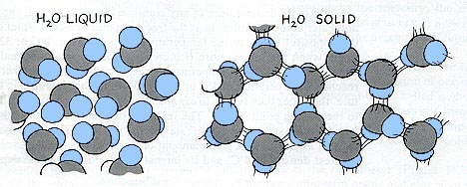

Water molecules in crystal form have an open-structured hexagonal

arrangement, so water expands upon freezing (water becomes less dense).

How Ponds Freeze Over

There are 2 key temperatures to remember. **Water is densest around 4°C** but it does not freeze until 0°C ....

As air above a lake cools, (e.g. from 16°C to 4°C) the water at the top contracts &  **becomes denser** than the water below the top layer. This cooler, denser water sinks and **warmer** **water rises** & replaces cooler water at the top.



This circulation of water, will eventually, bring the vast amount of the lake's water to 4°C. This is as dense as the water can get. Now, think ... water can't become any denser ... but it can become *less* dense ... once it freezes.

Remember, energy moves from high levels to low levels, so as the air continues to cool, (it's winter!!!), the warmer water will continue to lose energy to the air, drop below 4 °C and become *less* dense ... The UPPERMOST (top) layer of water *is especially vulnerable* to this temperature change and drop in density, because the top layer is *less insulated* from changes in air temperature.

So, as the top water layer cools below 4°C, the water incurs a *further decrease* in (water) density. Because the top layer of water is becoming less dense, the matter must be "spreading out", increasing its volume (EXPANDING!) Thus an expansion of the top layer's volume (same mass, with lower density = greater volume). So, the (colder) top layer becomes less dense than the water below. The water at the top stays on top, and ultimately freezes at 0°C and lower.

Density as a function of Temperature

from: *Conceptual Physics* p 319 (Paul Hewitt)

Question: Use the graph on the preceding page. Consider that climate change is a real issue, and that the

temperature of the Earth’s atmosphere and water is increasing

As water warms from 12 °C to 15 °C, what happens to its density? *Density of water decreases.

As this change in density occurs, using D=M/V what must then happen to the water’s

volume (space occupied)? *increases

As this happens, what will happen to the depth/height of sea level? *increase



[This Photo](https://ipkitten.blogspot.com/2012/07/friday-fantasies.html) by Unknown Author is licensed under [CC BY](https://creativecommons.org/licenses/by/3.0/)

**Check out: Sci Show How Cold-Blooded Animals Survive Winter:**

[**https://www.youtube.com/watch?v=tvzTbKULHmA**](https://www.youtube.com/watch?v=tvzTbKULHmA)

**Think: Why might cells “bust open” if frozen? Use your life experience and the**

**reading on a pond freezing over for a possible reason**

**\*\*\*\*\*\*\*\*\*\*\*\*\*\*\*\*\*\*\*\*\*\*\*\*\*\*\*\*\*\*\*\***

**So the big Take Home Messages are:**

* Matter has the characteristics of *mass and volume
* Matter can also be discussed in terms of its *extensive (changeable) and intensive (pretty constant under the same conditions of pressure and temperature
* In a closed system, during a chemical reaction *matter is conserved. It can’t just disappear
* Pressurized gases will move from a higher-pressure area to a lower pressure areas
* *Melting Point and density are two specific properties that can be used to identify samples of matter, assuming the samples are compared at the same temperature and pressure. These work because both properties are intensive properties (or constants)
* *The density of matter, like water, can change if *the temperature or pressure on a sample is changed.
* Lakes freezing is an example of an environmental change that occurs when the temperature changes, thus altering the density of water. Also, as water warms, it occupies more volume.