PRE-LAB ESTERIFICATION AND POLYMERIZATION

Esterification: The reaction between a carboxylic acid & an alcohol producing an ester & water as products.

This is a dehydration synthesis. The carboxylic acid loses an –OH & the alcohol loses an –H, thus forming H₂O. The remaining fragments bond to form the ester.

carboxylic acid + alcohol → ester + water

Example: ethanoic acid + propanol → propyl ethanoate + water

H O H H H H O H H H
| || | | | | || | | |
H−C−C−O−H + H−O−C−C−C−H ← H−C−C−O−C−C−C−H + H2O
| | | | | | | |
H H H H H H H H

Condensed or Structural Formula Name Odor Reactants

O
||
CH₃C―O―CH₂CH₂CH₂CH₂CH₂CH₂CH₂CH₃ octyl ethanoate orange ethanoic acid + octanol

O H H
|| | |
H―C―O―C―C―H ethyl methanoate raspberry methanoic acid + ethanol
| |
H H
O
||
CH₃C―O―CH₂CH₂CH₃ propyl ethanoate pear ethanoic acid + propanol

H O H H CH₃ H
| || | | | |
H―C―C―O―C―C―C―C―H pentyl ethanoate banana ethanoic acid + isoamyl alcohol
| | | | | (acetic acid)
H H H H H

O
||
CH₃CH₂ CH₂C―O―CH₂CH₃ ethyl butanoate pineapple butanoic acid + ethanol

Citation: taken directly from:http://www.lasalle.edu/academ/chem/ms/polymersRus/Resources/Synthesis.htm#chain (deactivated)
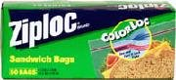 | Polymer Chemistry  Polymerization Reactions | 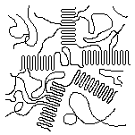

For polymerization to take place, the monomers must be capable of being linked to two (or more) other monomer molecules . Most of these reactions can be placed in one of two classifications: chain-reaction polymerization and step-reaction polymerization.

Chain-Reaction Polymerization
Chain-reaction polymerization, sometimes called addition polymerization, requires an initiator to start the growth of the reaction. The largest family of polymers, vinyl polymers, are produced by chain polymerization reactions. A good example is the free-radical polymerization of styrene, which is initiated by a free radical (R) that reacts with styrene. The compound that is formed still is a free radical, which can react again.

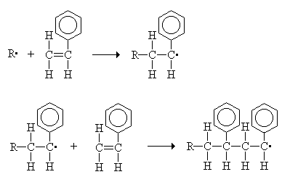

This reaction eventually leads to the formation of polystyrene, a portion of which is shown below. Polystyrene prepared by free-radical polymerization is
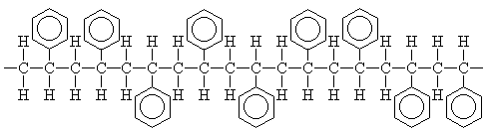

Polystyrene can be represented using a shorthand notation. |  | 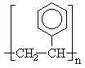

Styrene is an example of a vinyl monomer - small molecule(s) containing carbon-carbon double bonds. A few other important vinyl monomers are listed below. Some of these polymers are synthesized by methods involving initiators other than free radicals - carboanions, carbocations, or coordination compounds, for instance. Vinyl polymers are addition polymers, which have the same atoms as the monomer in their repeat units.
Monomer |  | Polymer
ethylene | 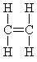 | polyethylene | 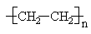
propylene | 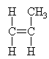 | polypropylene | 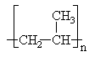
vinyl chloride | 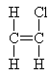 | poly(vinyl chloride) (PVC) | 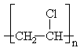
vinylidene chloride | 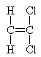 | poly(vinylidene chloride) (Saran) | 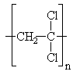
methylmethacrylate | 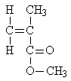 | poly(methylmethacrylate) (PMMA) | 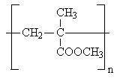
Produced by hydrolysis of poly(vinyl acetate) |  | poly(vinyl alcohol) (PVA) | 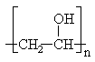

Step-Reaction Polymerization
In a step-reaction polymerization reaction, sometimes called condensation polymerization, the polymer chains grow by reactions that occur between two molecular species. An example is the polymerization reaction involving terephthalic acid and ethylene glycol, both of which are bifunctional.  Polymer formation begins with one diacid molecule reacting with one dialcohol molecule to eliminate a water molecule and form an ester. The ester unit has an alcohol on one end and acid on the other, which are available for further reactions. |  | 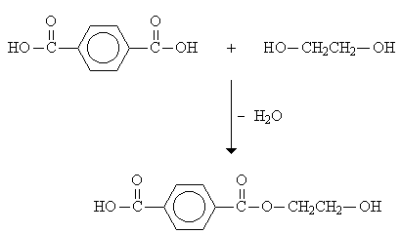
The eventual result is a polyester called poly(ethylene terephthalate) or more commonly, PET.
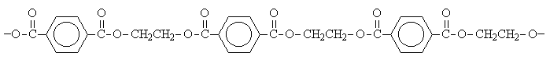

PET is the plastic in soda bottles. It can be represented with a shorthand notation. |  | 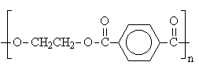
Polyesters are condensation polymers, which contain fewer atoms within the polymer repeat unit than the reactants because of the formation of byproducts, such as H₂O or NH₃, during the polymerization reaction. Most synthetic fibers are condensation polymers.
A few types of condensation polymers are listed below. In the table, the letters R & R' stand for carbon and hydrogen groupings.
Typical Monomers |  | Polymer Type
 | 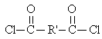 | polyester | 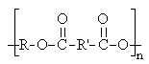
 | 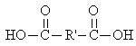 | polyamide (nylon) | 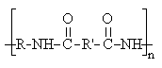
 |  | polyurethane | 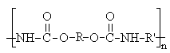
 | 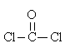 | polycarbonate | 