PRELAB: MEASUREMENT / DENSITY

This line is the “0” for the Vernier scale. Use its position to read the last value before the decimal point.
It often sits between two values on the main scale. Record the smaller value.
We now use the rest of the Vernier scale to determine the decimal places.

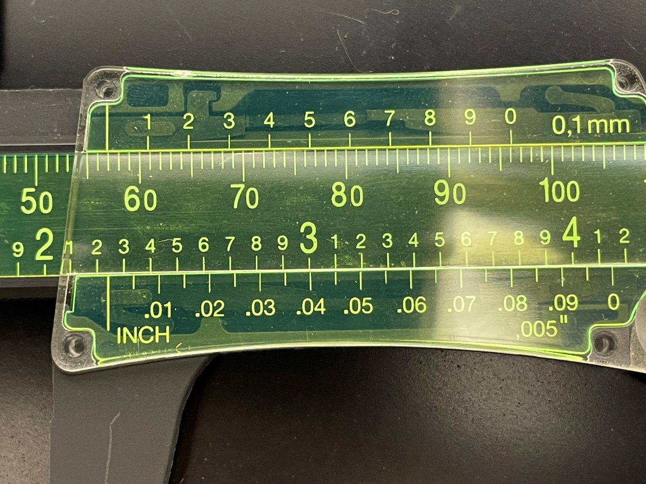

Find the first value on the Vernier scale which matches perfectly with the main scale. Use that value.

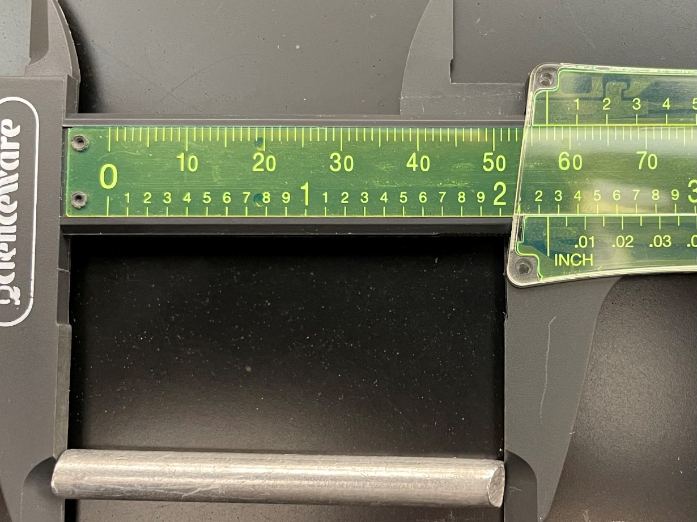

There are two criteria for your recorded measurements of length, width and height. The unit must have two decimal places and be recorded in the unit of centimeters. Our Vernier calipers measure in millimeters, so to get to centimeters you must divide each reading by 10.
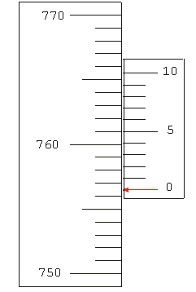
Read the scale and select the scale value, before the “0” of the Vernier …..

So, notice where the “0” on the Vernier is in the example to the left … It is between
The scale values of 756 and 757.

Select the lower value of 756.

Now, scan the Vernier system to find out where there is a match between the Vernier and the Scale. … Notice at the Vernier of 5, it matches perfectly with the Scale.

Hence, the measurement is 756.5 mm.

Divide this value by 10 to convert to centimeters.

This gives you 75.65 cm, which has 2 decimal places.

SCALE

VERNIER

https://faraday.physics.utoronto.ca/PVB/Harrison/Vernier/Vernier.html

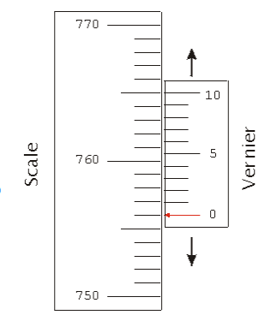
What if the Vernier, at 0 matches perfectly with the scale?

Notice that the “0” of the Vernier matches up precisely with the value of 756 on the scale.

Hence, this reading should be recorded as 756 mm.

Divide this value by 10, and you get 7.56 cm. This answer is what you should record. It meets the 2 criteria of your lab manual directions …. It has 2 decimal places and is in the unit of centimeters.

https://faraday.physics.utoronto.ca/PVB/Harrison/Vernier/Vernier.html

What if no Vernier measurement matches perfectly with the scale?
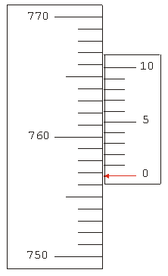
Read the scale and select the scale value, before the “0” of the Vernier …..

So, notice where the “0” on the Vernier is in the example to the left … It is between
The scale values of 756 and 757.

Select the lower value of 756.

Now, scan the Vernier system to find out where there is a match between the Vernier and the Scale. … Notice that the Vernier values of 7 and 8 are close. Here you may estimate by taking the smaller value (7) and breaking the space between 7 and 8 into 10 units.

Hence, the measurement is 756.71 mm.

Divide this value by 10 to convert to centimeters.

This gives you 75.671 cm, which may be rounded to 75.67 cm … meeting the 2 criteria of the lab.

SCALE

VERNIER

https://faraday.physics.utoronto.ca/PVB/Harrison/Vernier/Vernier.html

Reading a Graduated Cylinder:

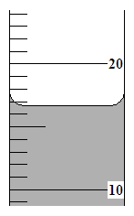
Whenever making a measurement with a graduated cylinder, the recorded value must be read to the smallest marked division and then have an estimated value.

So, study the following diagram representing part of a graduated cylinder:
₁₉
₁₈
₁₇
₁₆
₁₅
₁₄
₁₃
₁₂
₁₁

Notice that the smallest marked division is in 1 mL intervals.
I've tried to show you this, by writing in the values, between
10 and 20 ...trying to match the numbers up with the markings.

Since you can read the meniscus of the fluid to 1 mL, you should
then estimate one more value, and instead of recording a whole
number (such as 16 or 17) ... you should record to a tenth or 0.1 ml

A good answer would be 16.7 mL. Someone else may record 16.8 mL or 16.9 mL. Okay!
You see, the point to estimating one more value, beyond the marking is to better approximate
the reality of the volume. Recording 16.8 mL may be imperfect ... but it is far better than
recording 17 mL or worse yet, 16 mL.

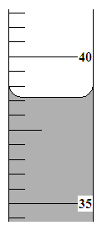
Look at this diagram: You'll notice that there are 10 divisions between 50 and 51 ... this means
50
51
each marked line represents a 0.1 mL. Thus, since you can read with
accuracy to 0.1 mL ... you should record the volume to 0.01 mL.
Hence, recording 50.7 mL is inappropriate.

A far better reading is 50.70 mL or 50.71 mL ... Such a reading lets
someone know that you used a graduated cylinder that had markings to
0.1 mL, because the reading is written to a hundredth of a mL (0.01 mL)

TRY THIS! Complete each of the following practice problems. Recall that the focus of this section is to practice recording measurements with the correct number of decimal places. Study the diagram. Then analyze
the division and check it off (). Once you know the smallest marked division, you know to what extent you
need to actually read the cylinder's volume.
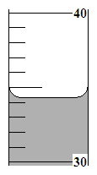
Division Analysis  The smallest marked  division is in | Reading between  the lines  So, this can be read to the | Answer  (mL)
1 mL  0.1 mL | 0.1 (tenth …1 decimal place)  or  0.01 (hundredth…2 decimal places) | 34.3
E.g.)

*****************************************************************************

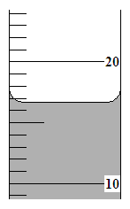
Division Analysis  The smallest marked division is in | Reading between  the lines  So, this can be read to the | Answer  (mL)
1 mL  0.1 mL | 0.1 (tenth …1 decimal place)  or  0.01 (hundredth…2 decimal places) | _________

1)

39

Division Analysis  The smallest marked division is in | Reading between  the lines  So, this can be read to the | Answer  (mL)
1 mL  0.1 mL | 0.1 (tenth …1 decimal place)  or  0.01 (hundredth…2 decimal places) | _________
2)

answers: 1) 16.8 mL your answer can have a ± 0.1 range
2) 39.71 mL your answer can have a ± 0.01 mL range

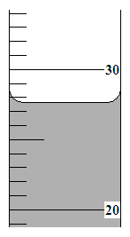
3)
Division Analysis  The smallest marked division is in | Reading between  the lines  So, this can be read to the | Answer  (mL)
1 mL  0.1 mL | 0.1 (tenth …1 decimal place)  or  0.01 (hundredth…2 decimal places) | _________

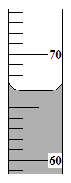

Division Analysis  The smallest marked division is in | Reading between  the lines  So, this can be read to the | Answer  (mL)
1 mL  0.1 mL | 0.1 (tenth …1 decimal place)  or  0.01 (hundredth…2 decimal places) | _________
4)

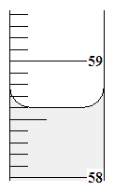

Division Analysis  The smallest marked division is in | Reading between  the lines  So, this can be read to the | Answer  (mL)
1 mL  0.1 mL | 0.1 (tenth …1 decimal place)  or  0.01 (hundredth…2 decimal places) | _________
5)

answers: 3) 27.8 mL your answer can have a ± 0.1 range
4) 66.6 mL your answer can have a ± 0.1 range
5) 58.60 mL your answer can have a ± 0.01 range

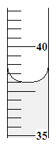
6)
Division Analysis  The smallest division is in | Reading between  the lines  So, this can be read to the | Answer  (mL)
1 mL  0.1 mL | 0.1 (tenth …1 decimal place)  or  0.01 (hundredth…2 decimal places) | _________

36

Division Analysis  The smallest division is in | Reading between  the lines  So, this can be read to the | Answer  (mL)
1 mL  0.1 mL | 0.1 (tenth …1 decimal place)  or  0.01 (hundredth…2 decimal places) | _________

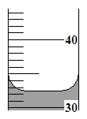
7)

39
answers: 6) 35.60 mL your answer can have a ± 0.01 range
7) 39.26 mL your answer can have a ± 0.01 range

