NAME ____________________________________________________

***“I propose to bring before you, in the course of these lectures, the Chemical History of a Candle…There is not a law under which any part of this universe is governed which does not come into play and is touched upon in these phenomena.”******Michael Faraday London 1850***(Atkins, PW Atoms, Molecules and Electrons)

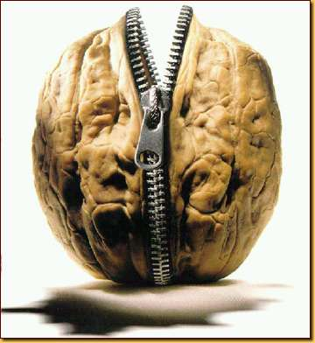

<http://blog.sellsiusrealestate.com/wp-content/nutshell1.jpg>

Well for those of us today, here “IT” is, in a nutshell

Candles are made of wax which is a **mixture** of various paraffin (pair-a-fin) compounds. Paraffin is the name given to a family of compounds made only of carbon and hydrogen. In these compounds there of at least 20 carbon atoms bonded to over hydrogen atoms per molecule. The various paraffin wax molecules **encase a cloth wick** running up through the center of the wax candle.

•First, you need to realize something about wicks. They may be made of glass fiber, but more

commonly, they are made of cloth. A new wick is coated in wax. An old wick has wax trapped inside

and around it. So whether it is new or used, a wick has a little wax associated with it.

•When the wick is first lit, the cloth chars (burns slightly and turns black), and that associated wax is

melted, vaporized (turned to gas) and combusted, releasing energy. This charring releases thermal

energy, and creates the first flame of a newly lit candle. Sometimes this charring process is poorly

accomplished, thus lighting a candle can sometimes require two or more tries.

•This original flame melts the solid wax of the candle itself. It turns the solid wax of the candle

to liquid wax. Liquid wax moves up the wick by capillary action and vaporizes **(turns into a gas)**

when it reaches the flame.

•Gaseous wax molecules (paraffins) dif­fuse out (exit) from the wick. The molecules of paraffin, now

existing in the gas phase are ripped apart (The bonds between carbon and hydrogen are broken, by the

energy of the flame. The fragments of the molecules encounter oxygen gas from the surrounding air.

•These fragments/atoms combust with (burn with / are oxidized by) the oxygen gas, and this chemical



reaction produces carbon dioxide, water, other small carbon-containing molecules, and even more

thermal energy. This produced thermal energy is essentially reconstitutes or continues the flame.

•The released thermal energy of the combustion helps to melt additional wax, which is

*wicked up* the wick as a liquid and the cycle continues. This cycle continues as long as

there is wick, oxygen and liquified wax to be wicked.

Essentially there is a cycle going on with a burning candle:

