A CAPSULE OF COVID CHEMISTRY
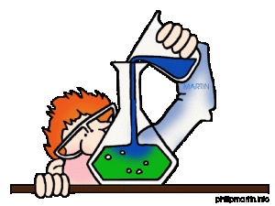
As the pandemic wore on, I began to ask some questions … like:

1) Why is the minimum standard alcohol content of hand sanitizer,
generally listed as 70% isopropyl alcohol OR 60% ethanol?
Why are they different percentages?

2) Why is 70% isopropyl alcohol a standard or why is 60% ethyl
alcohol (ethanol) a standard? For instance, would using 99.9%
isopropyl alcohol be better than 70% isopropyl alcohol?
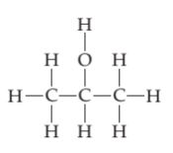

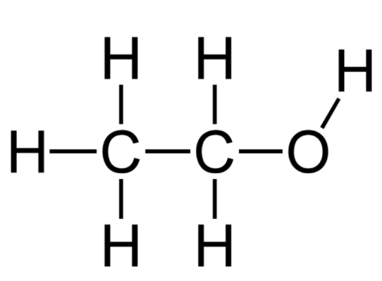

Ethanol or Isopropyl alcohol
ethyl alcohol Isopropanol or isopropyl alcohol
in liquor in rubbing alcohol
https://pediaa.com/difference-between-isopropyl-and-ethyl-alcohol/ https://byjus.com/chemistry/isopropyl-alcohol/

You may have heard that viruses may be enveloped or nonenveloped. Enveloped viruses are replicas of the original invading virus which tend to be wrapped in lipids (fats) and proteins which often come from the host cell (e.g. your cells).

It is believed that this envelope helps to protect the genetic material (RNA) of the virus by evading the host body’s defense system. Ethanol and Isopropyl alcohol can unravel and destroy these protective proteins and fats.
(https://www.cancer.gov/publications/dictionaries/cancer-terms/def/enveloped-virus)

Nonenveloped viruses lack this protective feature.

Of the two compounds (ethanol and isopropyl alcohol), ethanol is the better disinfectant, except when dealing with certain fungal infections and bacterial spores. It has a strong ability to kill enveloped viruses (e.g. herpes, influenza virus, and SARS CoV-2 [coronavirus]) as well as nonenveloped viruses (rhinovirus, norovirus )… and even HIV, when ethanol is in concentrations from 60% to 80%. So, the 60% is the minimum concentration that is an effective disinfectant … and 80% is the upper limit. (https://www.cancer.gov/publications/dictionaries/cancer-terms/def/enveloped-virus)

A mixture of 60% ethanol means that there are 60 mL of ethanol and 40 mL of water, dissolved into each other, in 100 mL of solution. A mixture of 80% ethanol means that there are 80 mL of ethanol and only 20 mL of water, dissolved into each other, in a 100 mL solution.

Of the two compounds, ethanol is a slightly smaller compound than isopropyl alcohol (study the diagrams). Note that many different words may be used to describe ethanol… such as molecular (molecule) organic, and of course, compound. We will learn what these terms mean, over the course of the semester.

When we do the math, (and we don’t need to do any math here …) there is a massively larger number of molecules in a 60% ethanol solution, than in an isopropyl solution of equal concentration. So, there are more disinfecting molecules in 60% ethanol, due to its smaller mass &/or size when compared to the same volume of isopropanol. This is why you do not NEED a greater concentration of ethanol, when comparing its sanitizing ability to a solution of isopropanol.

Conversely, the above means that due to the larger size of the isopropyl alcohol (also, an organic, molecular compound), in order to approximate the same efficacy of disinfection as 60% ethanol, you need a greater concentration (more molecules per unit volume) of isopropyl alcohol. https://ehs.umich.edu/wp-content/uploads/2020/05/70-alcohol-FAQs.pdf

Isopropyl alcohol is not terribly effective against nonenveloped viruses … but fairly effective (in higher concentrations) against enveloped viruses (like SARS CoV-2!) https://ehs.umich.edu/wp-content/uploads/2020/05/70-alcohol-FAQs.pdf

Now, you can go to amazon.com and purchase a very concentrated form, of isopropyl alcohol (99.9%). However, isopropyl alcohol is NOT a better disinfectant past a 70% concentration (70 mL/100 mL of solution). In fact, it’s worse!!! That is: 70% isopropyl alcohol is a better disinfectant than 99.9%!!! Hopefully, you are asking….why?

Well, there are 2 reasons. The first is that the 99.9% solution evaporates away too darn quickly. You need the alcohol to linger around to do its damage to the virus. So, the purer stuff needs to be mixed with water, to dilute it. The addition of water slows down the rate of evaporation. Molecules of alcohol and water are insanely attracted to each other (It’s due to something called hydrogen bonding). Anyway, the water inhibits the evaporation of the isopropyl alcohol, due to this mutual attraction between the molecules! So, here’s a lesson: More is not always better.
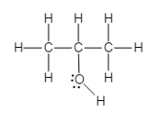

isopropanol molecule

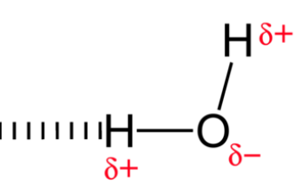
δ-
Dashes represent a weak attraction called a
Hydrogen Bond
water molecule
https://courses.lumenlearning.com/cheminter/chapter/hydrogen-bonding/
https://www.clutchprep.com/chemistry/practice-problems/115195/propyl-alcohol-ch3ch2ch2oh-and-isopropyl-alcohol-ch3-2choh-whose-space-filling-m

The above diagram shows us several things … It implies a “mixture” of two different compounds: water and isopropanol.

It shows / implies / hints at the:

- structures of isopropyl alcohol (isopropanol) and water
- number of covalent bonds in both the alcohol and water. Those covalent bonds are drawn as solid lines between the elements of H, C and O
- elemental composition of isopropanol (C, H, O) and water (H, O)
- formula for isopropanol: C₃H₇OH or the less frequently used, C₃H₈O.
- formula for water: H₂O
- fact that a hydrogen bond (dashed lines between the molecules) is different than a covalent bond (solid line) and that somehow a slightly negative oxygen (δ-) of the alcohol and a slightly positive hydrogen (δ+) of water are the cause of it all!!!

The second reason 99.9% is not as good a disinfectant as 70%, is how isopropyl disinfects. You see, upon contact, isopropyl alcohol disinfects (kills) by coagulating proteins into a muddled, useless mass (sort of like a rubbery mess of a fried egg). However, when the concentration is too high (beyond the 70% range), the alcohol tends to destroy the top layer of proteins, but this mess of coagulated proteins ends up protecting proteins buried beneath that mass. So, a less potent concentration of isopropyl alcohol, diluted with water is used to allow the isopropyl alcohol to permeate and destroy far more protein-wrapped viral particles. So, 70% isopropyl alcohol is a better disinfectant than 99.9%! Again, more is not always better. Stronger is not always better.

The FDA (Food and Drug Administration) has a list of hand sanitizers to avoid (https://www.fda.gov/drugs/drug-safety-and-availability/fda-updates-hand-sanitizers-consumers-should-not-use#products.

These 120 or so, different hand sanitizers appear to be contaminated with the alcohols, methanol and/or 1-propanol. You should avoid the use of these products because methanol can penetrate the skin and be absorbed into the body. Methanol poisoning can cause blindness. 1-propanol is not absorbed through the skin, but its ingestion (or its more probable inhalation) can cause respiratory inflammation (http://datasheets.scbt.com/sc-213408.pdf). Chemists at the FDA are worried that were someone with covid-19 to use a 1-propanol sanitizer, their already compromised lungs and/or respiratory system would suffer an even greater degradation.

The take home message through this all is to find hand sanitizers made only with ethanol or isopropanol (both with a proper concentration). Okay??

Assignment: Use the preceding reading on ethanol and isopropyl alcohol, and some independent research to answer the following questions. Copy and paste these questions into another word document. Turn in a hard copy of the questions and your responses to me. This is a credit-bearing assignment. Some of the answers come directly from the reading. Others will require some online research be sure to cite your sources for that research.

Paradiso: These answers should come from analysis of the reading.

1) What is meant by an enveloped and non-enveloped virus?

2) Record two reasons why 70% isopropyl alcohol is a more efficient disinfectant of the SARS-CoV-2 virus
than 99.9% isopropyl alcohol.

3) What symbol or convention is used to indicate covalent bonds, when drawing a molecular structure?

4) You find a hand sanitizer made with 80% ethanol. Is it okay for you to use? Explain…

Purgatorio: The answers to these question should involve some straight up research & a touch of work. Cite your sources!

5) Electrons make covalent bonds (chemical unions between atoms). How many electrons does a single
covalent bond represent?

6) Identify one side effect, should someone DRINK hand sanitizer made with isopropanol (isopropyl alcohol).
(Research and cite your source(s))

Inferno: Hell! This will require some creative research on your part. It will push you into realms of information and/or
knowledge, with which you are not yet familiar. I use these as primers for further learning and discussion.

7) Facts:
- C₂H₅OH (ethanol) is classified as an alcohol. CH₃OH (methanol) is an alcohol. C₄H₇OH (1-butanol)
is an alcohol.
- However, NaOH (sodium hydroxide) is NOT an alcohol, it is a strong base. KOH (potassium
hydroxide) is not an alcohol, it is also classified as a strong base.
- Both alcohols and bases have (OH) groups.
- However, the chemistry of an alcohol and a base are wildly different from each other.

Here are the questions: a) How can you differentiate between the written formula of an alcohol, vs. the
formula for a strong base? (Research and cite your source(s)). b) Should C₃H₇OH be
classified as an alcohol or strong base? Why – based upon your work for part a)?

