NAME___________________________ INTRO: INTEGRATED CHEMISTRY AND LIFE SCIENCES

**The first *chemical* system that we would describe as *living,* appeared about four billion years ago.**

Wilson et. al.

**Making mental connections is our most crucial learning tool, the essence of human intelligence; to forge links; to go beyond the given; to see patterns, relationships, context.**

Marilyn Ferguson

**Everything should be made as simple as possible … But no simpler.**

Albert Einstein

🌎🌎🌎🌎🌎🌎🌎🌎

I) Question #1: What does the Latin word "scire" or **scientia** (science) mean? * knowledge

A) science is concerned with prediction & explanation * (knowledge) of observed

of a variety of phenomena, ***using*** information

*The telephone book is full of facts but it doesn't contain a single idea* (Mortimer Adler)

information: recognizing facts, definitions, and measurements.

We need these

comprehension: using your own words to discuss a concept.

application: using a skill or concept in a new (un-taught / applied) situation

But these are the

stuff of an adult life today

analysis: recognizing/explaining patterns and meaning, identifying parts and wholes

synthesis: using various levels of learning to create something new

evaluation: making recommendations/policies, critiquing / making choices

II) Question #2: What is chemistry? (Gk: chemeia: black/metal working)



The branch of science, which studies the:

A) composition, structure, and properties of matter

B) * changes which matter undergoes

C) * energy associated with those changes

Can you think of examples of energy?

Can you think of examples of matter?

**At its very heart, chemistry is about transforming matter.**

III) Question #3: What is biology? [Gk: bios (life), logos (study of)]

The branch of science, which studies:

A) the interactions of living organisms, with each other, whether single celled, or multicellular

B) the molecular / chemical mechanisms of cells

C) the classification and behavior of organisms

D) how species evolve and interact with / between the abiotic and biotic factors of ecosystems

**At its very heart, biology is about the mechanisms which allow molecules of glucose (C6H12O6)**

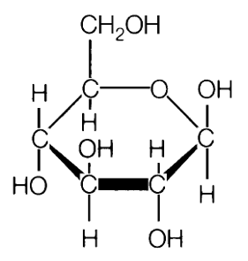

**to become**

**this.**

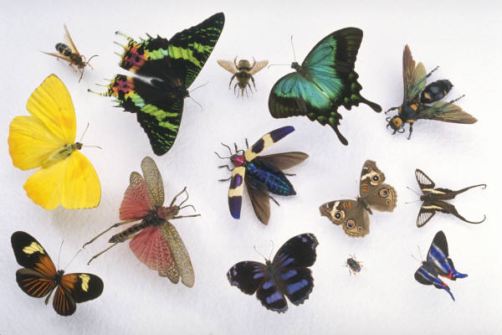

**\*\*\*\*\*\*\*\*\*\*\*\*\*\*\*\*\*\*\*\*\*\*\*\*\*\*\*\*\*\*\*\*\*\*\*\*\*\*\*\*\*\*\*\*\*\*\*\*\*\*\*\*\*\*\*\*\*\*\*\*\*\*\*\*\*\*\*\*\*\*\*\*\*\*\*\*\***

**WHAT YOU NEED TO KEEP IN MIND ... TO LEARN … TO INTEGRATE …**

**Broadly Speaking…**

1) Matter can be thought of as a combination of positive and negative particles. Everything else stems from

the number and/or the interaction of these positive and negative particles.

2) Major Reaction Chemistry reactions which involve Biochemistry…

Hydrolysis

Acid/Base

Reactions

(Loss / Gain

of H1+)

Redox Reactions

(Loss / Gain of electrons)

Condensation

… can be combined to help explain reaction chemistry including biochemistry

or rather they can help us understand

|  |  |
| --- | --- |
| chemicals that fuel | *coal, gasoline mixture , hydrogen gas, propane* |
| chemicals that are edible | *carbohydrates, fats, esters, water* |
| chemicals that clean | *soap, vinegar mixture, water, ammonia, alcohol* |
| chemicals that pollute | *arsenic, coal, soaps, toxins, plastics, pharmaceuticals* |
| chemicals that heal | *ibuprofen, aloe mixture, bandages, plastics* |
| chemicals that build | *steel, cellulose, plastics, silicon, Teflon, clay* |
| chemicals that decorate | *silver, paint mixture, plastics, dyes, papers, ink mixture* |
| chemicals of the economy | *oil, gold, copper, silicon, lithium, diamonds* |
| chemicals that conduct electricity | *copper, silver, gold, electrolytes* |
| chemicals of charm | *gold, diamonds, pheromones, makeup, shampoo* |
| chemicals of history | *gunpowder, A-bomb, aniline dyes, steel, salt, oil* |
| chemicals of crime | *potassium cyanide, gunpowder, alcohol, luminol, DNA* |
| chemicals of warfare | *iron, bronze alloy, munitions, plutonium, phosgene* |
| chemicals of entertainment | *alloys, cellulose, inks, plastics, paint, crayons, xenon gas* |
| chemicals of the brain | *dopamine, serotonin, vasopressin, oxytocin* |

3) There are a number of fields of study and focus in biology

… and many interesting questions!

***How can there be seedless grapes, and how do they reproduce?***

***Why is carbon monoxide extremely poisonous?***

***Why can't you tickle yourself (except your upper mouth***

***palate, with your pinkie finger …evidently)?***

***What causes the scent of fresh cut grass?***

***How do vitamins work?***

***What's all this fuss about stem cells?***

***How does my inhaler affect my breathing?***

***Why are frogs growing extra legs out of their legs?***

***Which came first, the chicken or the egg?***

***Does acid precipitation affect fish?***

***How do we explain bio-luminescence?***

***Do plants need air?***

***How much food is absorbed by a plant’s roots?*** *(answer…None!)*

edited: <http://www.kwantlen.ca/science/biology/what_is_biology.html>

**More Specifically…**

3) Chemical reactions are really due to the activity of electrons, and their Columbic attraction (positively

charged species attracting negatively charged species…. nuclei for electrons)

4) Atoms are DIFFERENT from Ions

a) Atoms may exist independently &/or atoms may bond to make molecules.

b) Ions may exist in aqueous solution &/or ions may bond to make ionic compounds.

c) Atoms have an overall charge of 0 because the number of protons and electrons are equal.

d) Ions have a + or – charge due to an unequal number of protons and electrons.

5) Ions and *electrons* are NOT the same thing

6) Issues of electrical conductivity are as follows:

a) Metals conduct electricity as solids or liquids.

b) Solutions with electrolytes (ions in water) conduct electricity.

c) Most molecular (covalent) substances do NOT conduct electricity

7) Changes in potential energy are central to most physical and chemical reactions

8) Chemical reactions occur only if old bonds are broken **AND** new bonds made…. In living systems, most

reactions must be **catalyzed**.

9) The rate of chemical reactions is controlled the number of effective collisions. The number of effective

collisions is affected by **temperature, concentration, and pressure** (especially for gases). The greater the

number of effective collisions between reactants, the greater the rate of the reaction.

10) On Mutations:

a) Not all mutations are bad … I mean, we are here, reading this!

b) A mutation is “good” or “bad” depending upon the environmental situation.

11) Populations evolve, not individuals

12) It may sound tame, but the macro-molecules like Proteins, Carbohydrates, Lipids and Nucleic Acids are

the very stuff of life … and seemingly common to all life, as we know it.

13) Most macro-molecular activity & structure, such as; enzymatic activity depends on weak interactions

whose individual energy is much less than that of a covalent bond. The stability of biological structures

depends on the sum of all these weak interactions (called intermolecular forces of attraction).

Additionally, enzymatic activity is very much dependent upon temperature. If the temperature were too

high, the protein (the enzyme) would unravel (denatures). If the temperature were too low, there would be

insufficient energy to create effective collisions between the enzyme and the substrate.

14) Life Functions are complicated, multi-step chemical reactions. These Life Functions, as a rule, must be

present, in order to be considered “living”… although there are some arguments about this…

An easy way to recall the 8 Life Functions is: **RRREGNTS** (close to REGENTS????)

(R) Respiration

(R) Regulation

(R) Reproduction

(E) Excretion

(G) Growth

(N) Nutrition

(T) Transport

(S) Synthesis

<http://www.goldiesroom.org/Note%20Packets/01%20Life%20Functions/00%20Life%20Functions%20Packet--WHOLE.htm>

15) The Life Functions interacting with each other produce a **metabolism** … and the chemical reactions that

operate an organism’s metabolism effectively maintain what is termed, **homeostasis**!

…. *AND THEN THERE IS THE PHYSICS OF CHEMISTRY AND OF BIOLOGY….*